introduction (week 1+)
Ben Bolker
03 September 2019

Introduction

Administrative trivia
- Instructors: Dr. Benjamin Bolker and Dr. Weijie Pang
- TAs: Nik Počuča, Steve Cygu, Aghigh Farhadi (marking)
- course web page: http://bbolker.github.io/math1mp
- course outline: http://bbolker.github.io/math1mp/admin/outline.html
- Grading
  - Assignments (10%)
  - Quizzes (5%)
  - Final project (5%)
  - Midterm tests (2 $×$ 20%)
  - Final exam (40%)
- homework assignment announcements policy
(web page, Avenue: not in class)

- Laptop policy
- Course material on web page and Avenue to Learn
- Expectations of professor and students
- Textbook (optional); Gries et al. Practical Programming 3d ed. (see outline)
- also see resources

Course content
reasonable balance among
- nitty-gritty practical programming instruction:
- … I just sat down in front of a text editor, with nothing but thoughts, and ended up with a program that did exactly what I wanted it to a few hours later … (ankit panda)
- conceptual foundations of computing/computer science
- context/culture of mathematical/scientific computing
- interesting applications

Installing Python
- CodeLab: http://www.turingscraft.com/go.html
- PythonAnywhere
- Everyone must have access to a computer with Python3 installed.
  - See installation instructions

Overview of math/sci computing

Using computers in math and science
- math users vs. understanders vs. developers
- develop conjectures; draw pictures; write manuscripts
- mathematical proof (e.g. four-colo(u)r theorem and other examples); computer algebra
- applied math: cryptography, tomography, logistics, finance, fluid dynamics, …
- applied statistics: bioinformatics, Big Data/analytics, …
- discrete vs. continuous math

Running Python
- via notebooks (http://mcmaster.syzygy.ca or on your own computer)
- via scripts + console (http://mcmaster.syzygy.ca/jupyter/user-redirect/lab)

Fun!
Hello, world (always the first program you write in a new computer language)
print('hello, python world!')
## hello, python world!
Python as a fancy calculator (REPL, Read-Evaluate-Print-Loop)
print(62**2*27/5+3)
## 20760.6
reference: Python intro section 3.1.1

Interlude: about Python
- programming languages
  - Python: scripting; high-level; glue; general-purpose; flexible
  - contrast: domain-specific scripting languages (MATLAB, R, Mathematica, Maple)
  - contrast: general-purpose scripting languages (Perl, PHP)
  - contrast: general-purpose compiled languages (Java, C, C++) (“close to the metal”)
- relatively modern (1990s; Python 3, 2008)
- currently the 5th most popular computer language overall (up from 8th in 2015); most popular for teaching
- well suited to mathematical/scientific/technical (NumPy; SciPy; Python in Finance)
- ex.: Sage; BioPython

the “prime walk” (from math.stackexchange.ca)
- start at the origin, heading right, counting up from 1
- move forward one space, counting up, until you find a prime
- turn 90${}^{∘}$ clockwise
- repeat steps 2 and 3 until you get bored
code here (bbolker.github.io/math1mp/code/primewalk.py)
Note:
- easier to understand/modify than write from scratch
- build on existing components (modules)

Interfaces
- integrated development environment (IDE), command line/console (Spyder)
- programming editor
- notebooks
- not MS Word!

Features
- syntax highlighting, bracket-matching, hot-pasting
- integrated help
- integrated debugging tools
- integrated project management tools
- most important: maintain reproducibility; well-defined workflows

Assignment and types (PP $\S2.4$)
- superficially simple
  - set aside memory space, create a symbol that points to that space
  - = is the assignment operator (“gets”, not “equals”)
  - <variable> = <value>
  - variable names
    - what is legal? (names include letters, numbers, underscores, must start with a letter)
    - what is customary? convention is variables_like_this (“snake case”)
    - what works well? v vs. temporary_variable_for_loop
    - same principles apply to file, directory/folder names

- variables are of different types
  - built-in: integer (int), floating-point (float), complex, Boolean (bool: True or False),
  - dynamic typing
    - Python usually “does what you mean”, converts types when sensible
  - strong typing
    - try print(type(x)) for different possibilities (x=3; x=3.0; x="a")
    - what happens if you try x=a?
    - don’t be afraid to experiment!

Examples
x=3
y=3.0
z="a"
q=complex(1,2)
type(x+y) ## mixed arithmetic
type(int(x+y)) ## int(), float() convert explicitly
type(x+z)
type(q)
type(x+q)
type(True)
type(True+1) ## WAT
[^2](As Dive into Python says in a similar context, “Ew, ew, ew! Don’t do that. Forget I even mentioned it.”)
Check out the Python tutor for these examples

Arithmetic operators, precedence
- exponentiation (**)
- negation (“unary minus”) (-)
- multiplication/division (*,/,//=integer division,%=remainder (“modulo”))
- addition/subtraction (+, - (“binary”))
Use parentheses when in doubt!
Puzzle: what is -1**2? Why?

Logical operators (PP $\S5.1$)
- comparison: (==, !=)
- inequalities: >, <, >=, <=,
- basic logic: (and, or, not)
- remember your truth tables, e.g. not(a and b) equals (not a) or (not b)
a = True; b = False; c=1; d=0
a and b
not(a and not b)
a and not(b>c)
a==c ## careful!
not(d)
not(c)

operator precedence
- remember order of operations in arithmetic
- not has higher precedence than and, or. When in doubt use parentheses …
From CodingBat:
We have two monkeys, a and b, and the parameters a_smile and b_smile indicate if each is smiling. We are in trouble if they are both smiling or if neither of them is smiling. Return True if we are in trouble.
monkey_trouble(True, True) → True
monkey_trouble(False, False) → True
monkey_trouble(True, False) → False

Truth tables
A | B | A and B | A or B | not A
True | True | True | True | False
True | False | False | True | False
False | True | False | True | True
False | False | False | False | True

Logical expressions
- The logical expression: not not a and not b or a is equivalent to ((not (not a)) and (not b)) or a since the operator not takes precedence over the operators and and or.
- So if a = True and b = False this evaluates to True
- Since not not a is equivalent to a, we can simplify the expression to just (a and not b) or a.
- Can we simplify this further?
What can we do with not a and not b ?

More CodingBat problems
- squirrel_play
- cigar_party

String operations (PP chapter 4)
reference: Python intro section 3.1.2
- Less generally important, but fun
- + concatenates
- * replicates and concatenates
- in searches for a substring
a = "xyz"
b = "abc"
a+1 ## error
a+b
b*3
(a+" ")*5
b in a

CodingBat problems:
- make_abba
- make_tags
One more useful string operation: len(s) returns the length (number of characters)

Indexing and slicing

Indexing
- Extracting elements is called indexing a list
- Indexing starts from zero
- Negative indices count backward from the end of the string
(-1 is the last element)
- Indexing a non-existent element gives an error
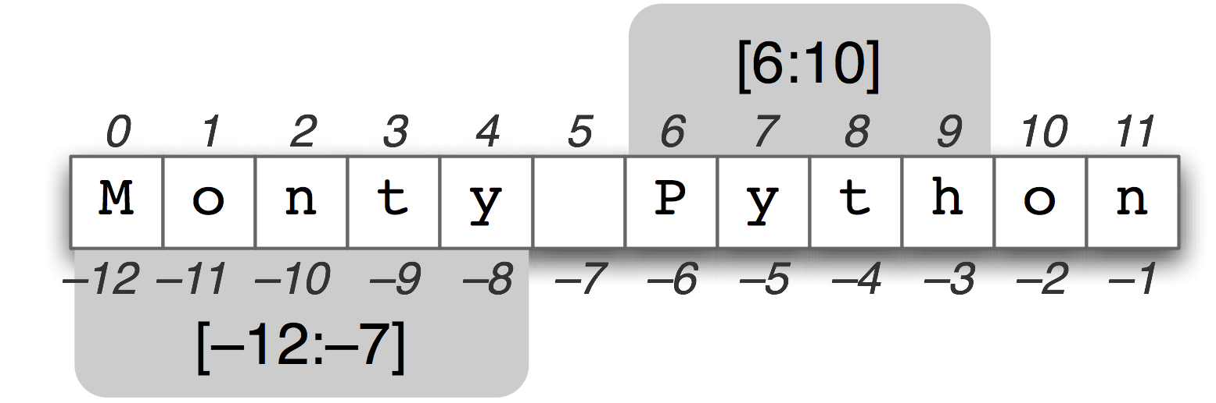
slicing

Slicing
- Extracting (consecutive) sets of elements is called slicing
- Slicing non-existent element(s) gives a truncated result
- Slicing specifies start, end, step (or “stride”)
- Leaving out a bit goes from the beginning/to the end
- Slicing works on strings too!
x[:] # everything
x[a:b] # element a (zero-indexed) to b-1
x[a:] # a to end
x[:b] # beginning to b-1
x[a:b:n] # from a to b-1 in steps of n
- generate a list of odd numbers from 3 to 15
- reverse a string?

String slicing practice
From CodingBat:
- first_two
- first_half

Methods
- Objects in Python have classes (string, integer, etc.)
- Classes have methods - things you can to do the objects
- You use a method by calling .()
  - yes, this seems weird at first.
- methods may or may not have arguments

String methods: examples
Strings have lots of methods, for example:
x = "abcdef"
x.upper()
## 'ABCDEF'
x.capitalize()
## 'Abcdef'
x.endswith("f")
## True
x.startswith("qrs")
## False
x.islower()
## True

