matplotlib
Ben Bolker
11 November 2019
## /usr/lib/python3/dist-packages/matplotlib/__init__.py:1352: UserWarning: This call to matplotlib.use() has no effect
## because the backend has already been chosen;
## matplotlib.use() must be called *before* pylab, matplotlib.pyplot,
## or matplotlib.backends is imported for the first time.
##
## warnings.warn(_use_error_msg)

matplotlib
- matplotlib is the Python module for making graphics and plotting data
- we’ve already used it, in the primewalk example at the beginning of the course
- we will explore some basic capabilities of matplotlib, especially the matplotlib.pyplot submodule
- resources: matplotlib cheat sheet, gallery, tutorial

basic setup
- if you have Anaconda installed, matplotlib should already be installed (for use in Spyder or Jupyter notebooks
- matplotlib is already install on syzygy
- once installed, use
import matplotlib.pyplot as plt
import numpy as np ## we almost always use matplotlib with numpy
- plotting basics (“hello, world” for plots)
x = np.arange(5)
plt.plot(x)
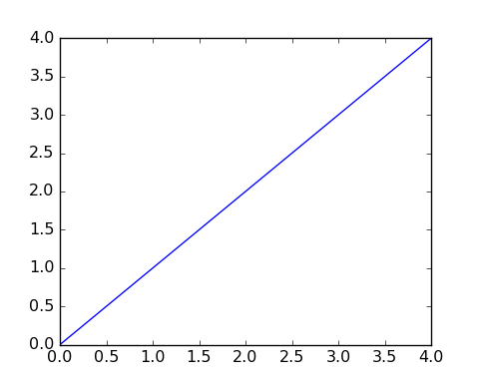

showing/saving plots
- if using Spyder (or PyCharm), plots might just show up
- in Jupyter notebooks, put the magic %matplotlib inline in a code chunk to display plots
- use plt.show() to show plots otherwise
- use plt.savefig("filename.png") to save the figure to a file on disk (you can click to open it, or include it in a Word document, or …)

basic plots
- a list, tuple, or 1-D ndarray will be treated as the y-axis values for a plot; the indices (0, … len(x)-1) are the x-axis points
y = np.array([1,3,2,4,8,5])
plt.plot(y)
plt.show(y)
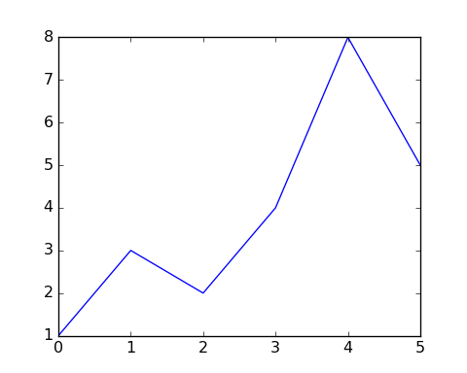
plt.savefig("example1.png")
plt.close()

more principled plots
- plt.plot, plt.show are “magic” functions
- better to use plt.subplots()
- returns a tuple with an object representing the whole figure and an object representing the axes (plot area)
fig, ax = plt.subplots()
ax.plot(y) ## create plot
fig.savefig("example2.png") ## save figure

scatter plots
- .scatter() produces a scatterplot
- points instead of lines
- adds a margin around the points
fig, ax = plt.subplots()
np.random.seed(101)
x = np.random.randint(5,size=len(y))
ax.scatter(x,y) ## create plot
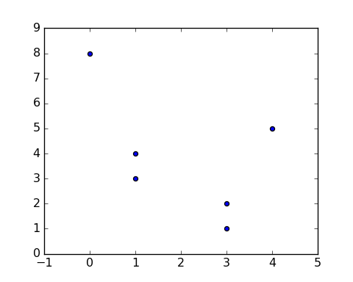

Putting more than one thing on a plot
You can put more than one .plot() or .scatter() on the same set of axes
fig, ax = plt.subplots()
x = np.arange(0,5*np.pi,0.1)
y = np.sin(x)
ax.plot(x,y)
ax.plot(x+np.pi/2,y,color="red")
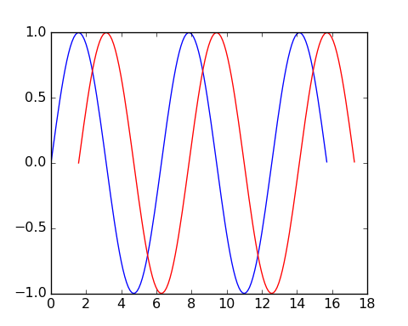

Modifying plot appearance
- color
- marker (+, o, x, …)
- linewidth
- linestyle (-, --, -., None, …)
fig, ax = plt.subplots()
x = np.arange(0,5*np.pi,0.1)
y = np.sin(x)
ax.plot(x,y,marker="x",linestyle="--",color="purple")
ax.plot(x+np.pi/2,y,linewidth=2,color="blue")
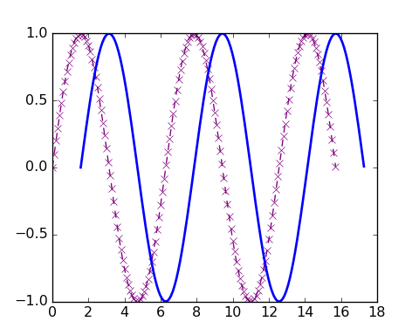

More modifications
Shortcuts for color (first letter), marker, line style … see plot documentation
x = np.arange(0., 5., 0.2)
plt.plot(x, x, "r--")
plt.plot(x, x ** 2, "bs")
plt.plot(x, x ** 3, "g^")
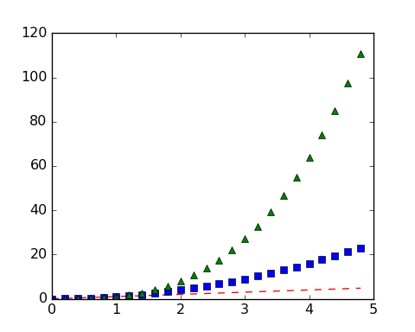

More decorations
- add titles, axis labels …
- titles (ax.set_xlabel(), ax.set_ylabel())
- change limits
- title: fig.suptitle() (refers to figure, not individual axes)
- legend: need to specify label= for each plot element, e.g.
fig, ax = plt.subplots()
x = np.arange(0,5*np.pi,0.1)
y = np.sin(x)
ax.plot(x,y,label="first")
ax.plot(x+np.pi/2,y,color="red",label="second");
ax.set_xlim([0,25])
ax.legend(fontsize=8)
ax.set_xlabel("the x-axis label")
ax.set_ylabel("the y-axis label")
fig.suptitle("my plot")
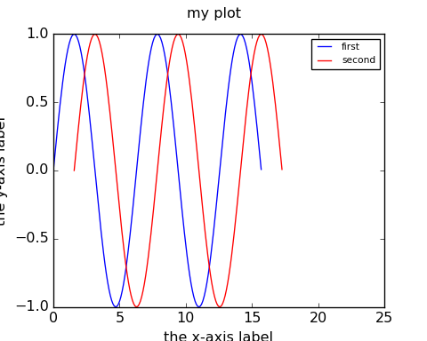

other plot types
- matplotlib can also make bar charts, histograms, and pie charts
- plt.bar(cat, values) produces a bar chart with the items from the list or array cat (for “categories”) displayed along the x-axis, and above each category, a bar with height equal to value[i], for the i’th category.
- Here’s a bar chart with categories a through e and values given by an array of random integers:
fig, ax = plt.subplots()
cat = np.array(["a", "b", "c", "d", "e"])
values = np.random.randint(10, size=5)
x_pos = np.arange(len(values))
ax.set_xticklabels(cat);
ax.bar(x_pos,values);
fig.savefig("bar.png")
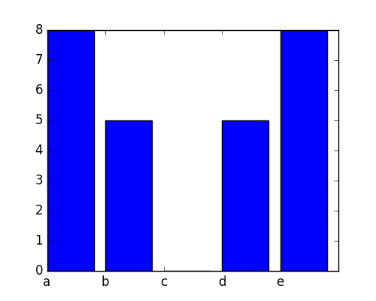
bar plot

histograms
- a histogram is a visual representation of the distribution of continuous numerical data (Wikipedia)
- it’s a bar graph whose categories are intervals that divide some specified range into disjoint bins
- bins are usually (but not always) of equal width
  - each bin shows a bar or rectangle whose height is proportional to the frequency of the numbers falling within that range
fig, ax = plt.subplots()
f = open("../data/cherrytree.txt", "r")
height = []
diam = []
for L in f:
vals = np.array(L.split(),dtype="float")
diam.append(vals[1])
height.append(vals[2])
ax.hist(height);
fig.savefig("hist.png")
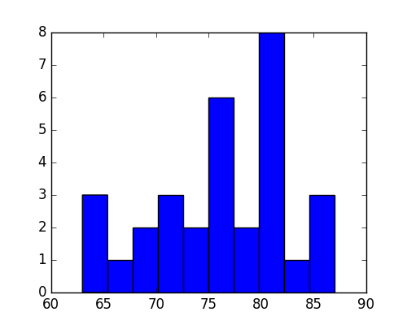

better bin widths
fig, ax = plt.subplots()
ax.hist(height,bins=6);
fig.savefig("hist2.png")
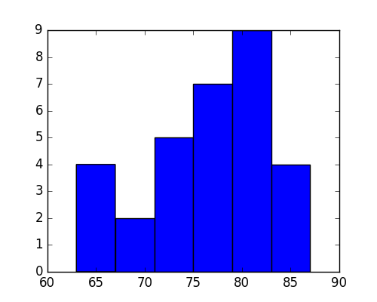

multiple subfigures in a plot
fig, ax = plt.subplots(1,3)
fig.set_size_inches((6,3))
ax[0].hist(height,bins=6);
## (array([4., 2., 5., 7., 9., 4.]), array([63., 67., 71., 75., 79., 83., 87.]), <a list of 6 Patch objects>)
ax[0].set_xlabel("height")
ax[1].hist(diam,bins=6);
## (array([ 3., 12., 7., 3., 5., 1.]), array([ 8.3 , 10.35, 12.4 , 14.45, 16.5 , 18.55, 20.6 ]), <a list of 6 Patch objects>)
ax[1].set_xlabel("diameter")
ax[2].scatter(height,diam)
ax[1].set_xlabel("height")
ax[2].set_xlabel("diameter")
fig.savefig("hist3.png")
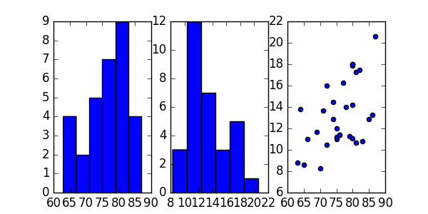

The logistic map
- The discrete logistic map, $x_{t+1}=rx_{t}(1−x_{t})$, is a simple model for populations that has interesting dynamical properties.
- It is similar to the continuous logistic model $\frac{dx}{dt}=rx(1−x)$, but has very different dynamics when $r$ is large.
- It has equilibria at $0$ and $x^{*}=1−1/r$. For $r>1$ it mimics exponential (geometric) growth for $x_{t}≪1$.

logistic function
- return the sequence of numbers obtained by applying the logistic map repeatedly (nt times), starting with x0 and using the value r:
def logist_map(r,nt=100,x0=0.5):
""" run the logistic map """
x = np.zeros(nt)
x[0] = x0
for t in range(1,nt):
x[t] = r*x[t-1]*(1-x[t-1])
return(x)

x = logist_map(r=1.5, nt=8)
print(x[:4],"\n",x[4:])
## [0.5 0.375 0.3515625 0.34194946]
## [0.33753004 0.33540527 0.33436286 0.33384651]

It’s easier if we plot the sequences:
fig, ax = plt.subplots()
y1 = logist_map(1.5)
y2 = logist_map(2)
y3 = logist_map(3)
ax.plot(y1)
ax.plot(y2)
ax.plot(y3,'r')
fig.savefig("pix/lm0.png")
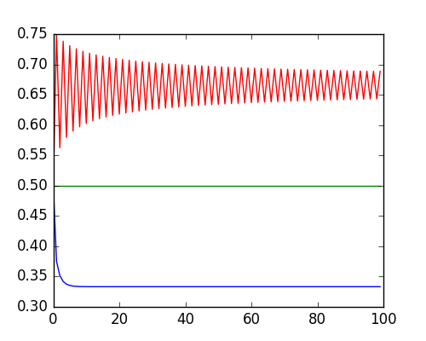

What if we make a function to do this?

- The behaviour of the sequence generated by the discrete logistic map depends strongly on $r$
- Let’s plot the elements of these sequences for a range of $r$ values.
- In the following, rvals is an array of r values ranging from 1.1 to 3.9 in steps of 0.05.
- For the ith value in this array, the ith column of the array b will hold the sequence of numbers generated with this r value. A scatter plot, with r values along the x-axis, and sequence values along the y-axis can be used to visualize the sequences generated for each r value in the array.
rvals = np.arange(1.1,3.9,0.05)
b = np.zeros((500,len(rvals)))
for i in range(len(rvals)):
b[:,i] = logist_map(r=rvals[i],nt=500)

- np.tile(x,s) takes a vector and replicates it a number of times specified by the tuple s
fig, ax = plt.subplots()
rmat = np.tile(rvals,(500,1))
ax.scatter(rmat,b)
fig.savefig("pix/lm1.png")
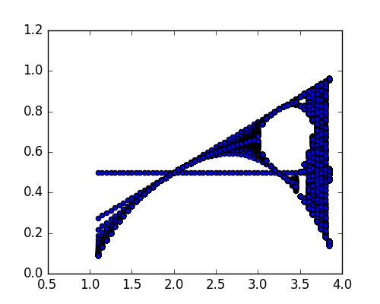

now without the transient
fig,ax = plt.subplots()
b2 = b[250:,]
rmat2 = np.tile(rvals,(250,1))
ax.scatter(rmat2,b2)
fig.savefig("pix/lm2.png")
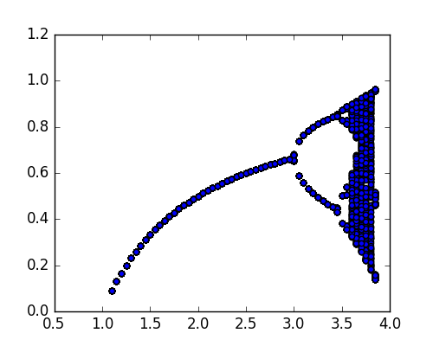

now as an image plot
fig,ax = plt.subplots()
ax.imshow(b2,aspect="auto",extent=[1.1,3.9,250,500],interpolation="none")
fig.savefig("pix/lm3.png")
