numerical integration; more on random numbers; Game of Life
Ben Bolker
19 November 2019

numerical integration
In first year calculus the definite integral of a function $f(x)$ over the interval $[a,b]$ is defined to be the limit of a sequence of Riemann sums:
$$\int_{a}^{b}{f}(x) dx=\underset{n→∞}{\text{lim}}\sum_{i=0}^{n−1}{f}(x_{i}) Δx$$
where $Δx=(b−a)/n$ and $x_{i}=a+i⋅Δx$ - So the definite integral can be approximated using Riemann sums for suitably large values of $n$

coding Riemann sums in numpy
import numpy as np
def num_int(f, a, b, n):
dx = (b-a)/n
x = np.arange(a, b, step = dx)
y = f(x)
return y.sum() * dx
Note this takes a function f as input.

example
Try approximating $\int_{0}^{1}{x^{2}} dx$ with $n=\{10,50,5000\}$
def x_squared(x):
return x ** 2
approx1 = num_int(x_squared, 0, 1, 10)
approx2 = num_int(x_squared, 0, 1, 50)
approx3 = num_int(x_squared, 0, 1, 5000)
print(approx1, approx2, approx3)
## 0.2850000000000001 0.3234 0.33323334
We could create an adaptive version of this that keeps trying larger values of n until the results are “close enough”

refinements
- num_int uses the left endpoint rule to compute Riemann sums for a function $f(x)$
- In Section 7.7 of Dr. Stewart’s Calculus textbook, several other methods are presented.
- The right endpoint and midpoint rules are simple variations of the left endpoint rule:
$$\begin{matrix}\int_{a}^{b}{f}(x) dx & =\underset{n→∞}{\text{lim}}\sum_{i=0}^{n−1}{f}(x_{i+1}) Δx \text{right endpoint} \\ \int_{a}^{b}{f}(x) dx & =\underset{n→∞}{\text{lim}}\sum_{i=0}^{n−1}{f}\left((x_{i}+x_{i+1})/2\right) Δx \text{midpoint}\end{matrix}$$

other rules
- trapezoid rule: use the average of the approximations obtained by using the left and right endpoint rules
- Simpson’s method: use quadratic functions (parabolas) instead of linear functions to interpolate
$$\int_{a}^{b}{f}(x) dx≈∑(Δx/6)\left(f(x_{i})+4f((x_{i}+x_{i+1})/2)+f(x_{i+1})\right)$$
We’ll write a function that implements any of these rules, and check it with $\int_{0}^{1}{x^{2}} dx$ and $\int_{0}^{1}{x^{3}} dx$.

symbolic integration
from sympy import *
x = Symbol('x')
integrate(x**2,x) ## no "plus a constant"
## x**3/3
Or definite integrals:
integrate(x**2,(x,0,1))
## 1/3
But:
integrate(log(x)**x,x)
## Integral(exp(x*log(log(x))), x)
(see Wikipedia for more information on symbolic integration)

area of a circle
- what if we want to figure out the area of a circle with radius 1?
- (we already know it’s 1)
- because $x^{2}+y^{2}=1$, one quadrant is traced out by the function $y=\sqrt{1−x^{2}}$ from $x=0$ to 1
- (we could do this symbolically: = $1/2{\left(x\sqrt{1−x^{2}}+{\text{sin}}^{−1}(x)\right)}_{0}^{1}$)
integrate(sqrt(1-x**2),x)
## x*sqrt(-x**2 + 1)/2 + asin(x)/2
integrate(sqrt(1-x**2),(x,0,1))
## pi/4
- Let’s try it with the integrator from above

Monte Carlo integration
- “Monte Carlo” in general refers to any algorithm that uses (pseudo) random numbers
- a Monte Carlo method to approximate $π$:
- draw a square of area 1
- inscribe a quarter circle (with radius = 1)
- the area $A$ of the quarter-circle is equal to $π/4$
- randomly throw darts in the square and count the number of them that fall within the circle (i.e. $x^{2}+y^{2}<1$)
- the ratio of the number that fall into the circle to the total number thrown should be close to the ratio of the area of the circle to the area of the square
- the more darts thrown, the better the approximation.

- numpy.linspace(start,stop,num, endpoint=True) is a more convenient way to generate evenly (linearly) spaced values
- by default it includes the endpoint (unlike numpy.arange())

import matplotlib.pyplot as plt
import numpy.random as npr
x = np.linspace(0,1,101)
y = np.sqrt(1-x**2)
fig, ax = plt.subplots()
ax.plot(x,y)
xr = npr.uniform(size=200)
yr = npr.uniform(size=200)
incirc = xr**2+yr**2<1
ax.plot(xr[incirc],yr[incirc],"b*")
ax.plot(xr[np.logical_not(incirc)],yr[np.logical_not(incirc)],"ro")
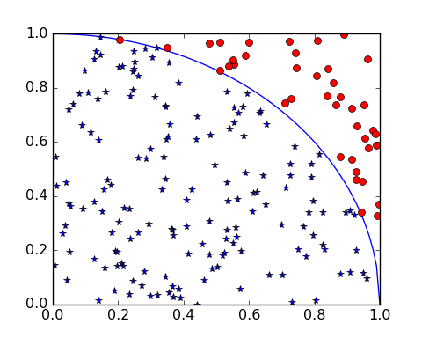

continuing
- now we just have to count the number
from math import pi
incirc.mean()*4/pi
## 1.0185916357881302

another example
Overlap of circles at (1.5,2.5) (radius 1), (4,3) (radius 3), (1,2) (radius 2)
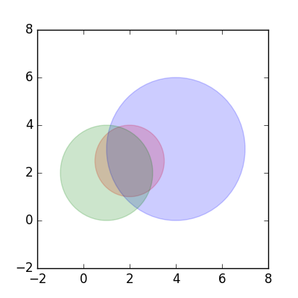
import numpy.random as npr
import numpy as np
c = ((2,2.5),(4,3),(1,2))
r = (1.5,3,2)
npr.seed(101)
x = npr.uniform(c[0][0]-r[0],c[0][0]+r[0],size=1000000)
y = npr.uniform(c[0][1]-r[0],c[0][1]+r[0],size=1000000)
tests = np.tile(True,10**6) ## boolean vector
def incirc(x,y,ctr,radius):
dsq = (x-ctr[0])**2+(y-ctr[1])**2
return(dsq<radius**2)
for c0,r0 in zip(c,r): ## zip() rearranges lists
tests = tests & incirc(x,y,c0,r0)
print(np.mean(tests))
## 0.78613
## 0.658081
## 0.48976
print(r[0]**2*np.mean(tests))
## 1.10196
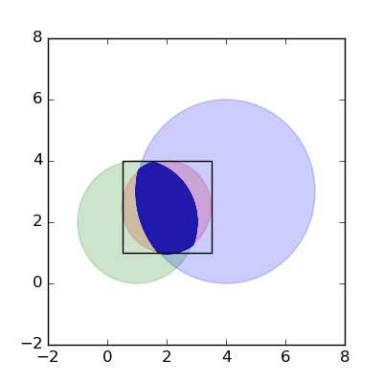

More on random number generation

(Pseudo)random numbers
- From Wikipedia: “Anyone who considers arithmetical methods of producing random digits is, of course, in a state of sin” (von Neumann) (original paper) … “We are here dealing with mere ‘cooking recipes’ for making digits; probably they can not be justified, but should merely be judged by their results …”

linear congruential generators
- $x_{n}=(ax_{n−1}+c)\text{mod}m$
- or x = (a*x +c ) % m
- from here:
Simple example:
x = [5] ## starting value
a,c,m = 2,3,10 ## constants
for i in range(9):
newx = (a*x[-1]+c) % m
x.append(newx)
print(x)
## [5, 3, 9, 1, 5, 3, 9, 1, 5, 3]

Park-Miller minimal standard generator
a,c,m = 16807,0,2147483647
x = [5]
for i in range(9):
newx = (a*x[-1]+c) % m
x.append(newx)
print(np.array(x)/m)
## [2.32830644e-09 3.91318463e-05 6.57688941e-01 7.78026611e-01
## 2.93250660e-01 6.63836187e-01 9.47959316e-02 2.35223081e-01
## 3.94323584e-01 3.96482029e-01]

run for longer
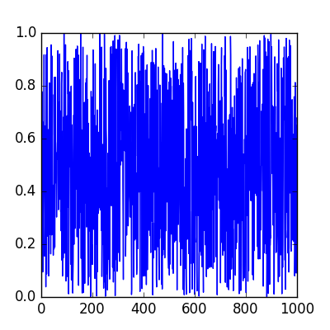
random values
- using numpy: reference
import numpy.random as npr
a = npr.rand(1000)
- can also do useful things like
  - pick from a list: choice() (with or without replacement)
  - shuffle values: shuffle() (in-place)
  - pick values from different distributions
  - sample from a large range of non-uniform distributions (Poisson, Normal, binomial …)
- using random number generators for serious work:
  - know what generator is used
    - Mersenne twister: period of $2^{219937}−1$, very widely used
  - set the seed: seed()
- using random numbers for cryptography: be super-paranoid: see e.g. this

Conway’s game of life
Rules:
- set up a rectangular array of cells
- set some cells to 1 (“alive”) and some to 0 (“dead”)
- live cells with exactly 2 or 3 neighbours live; others die
- dead cells with exactly 2 neighbours become living; others stay dead

pieces
- life_init(size, init_dens): set up a size*size 2D array of zeros; set a density init_dens to 1
- life_step(w,nw): run the Conway rules on an array w and return the new array nw
- count_nbr(w,i,j): count the number of neighbours in the 3x3 square around w[i,j]
- life_show(w, ax): plot an image of the current array w on axes ax

examples
import os
import matplotlib.pyplot as plt
os.chdir("../code")
from life import *
os.chdir("../notes")
w = life_init()
fig, ax = plt.subplots()
life_show(w, ax)
fig.savefig("pix/life1.png")
nw = w.copy()
(nw, w) = life_step(w,nw)
life_show(w, ax)
fig.savefig("pix/life2.png")
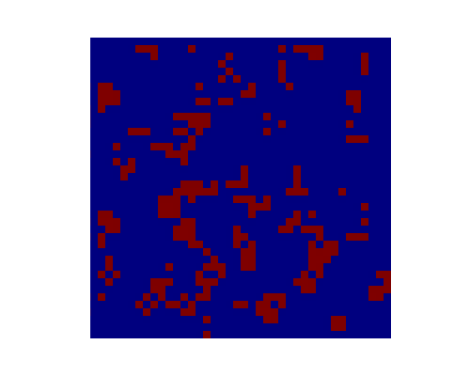
fig, ax = plt.subplots(5,5)
for i in range(ax.shape[0]):
for j in range(ax.shape[1]):
nw, w = life_step(w,nw)
life_show(w, ax[i][j])
fig.savefig("pix/life3.png")
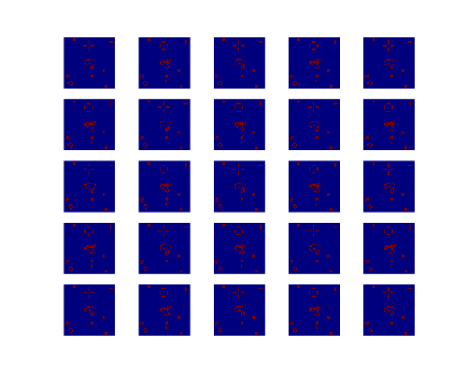
fig, ax = plt.subplots(5,5)
for i in range(ax.shape[0]):
for j in range(ax.shape[1]):
for k in range(10):
life_show(w, ax[i][j])
nw, w = life_step(w,nw)
fig.savefig("pix/life4.png")
