conditionals and flow control (week 2)
Ben Bolker
19:39 17 September 2019

Lists and indexing (PP chapter 8)
reference: Python intro section 3.1.3

Lists
- Use square brackets [] to set up a list
- Lists can contain anything but usually homogeneous
- Put other variables into lists
- range() makes a range but you can turn it into a list with list()
  - Set up a list that runs from 101 to 200
- Indexing and slicing lists works almost the same way as indexing and slicing …
- Put lists into lists! (“yo dawg …”)
  - difference between an item from a list (indexing, x[0]) and a one-element list (slicing, x[0:1])

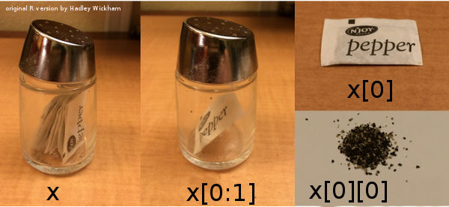

Other list operations
- Lots of things you can do with lists!
- Lists are mutable
x = [1,2,3]
y = x
y[2] = 17
print(x)
## [1, 2, 17]
Check it out at Python Tutor
- operators vs. functions vs. methods x+y vs. foo(x,y) vs. x.foo(y)
  - list methods
  - appending and extending:
x = [1,2,3]
y = [4,5]
x.append(y)
print(x)
## [1, 2, 3, [4, 5]]
x = [1,2,3] # reset x
y = [4,5]
x.extend(y)
print(x)
## [1, 2, 3, 4, 5]
Can use + and += as shortcut for extending:
x = [1,2,3]
y = [4,5]
z = x+y
print(z)
## [1, 2, 3, 4, 5]

list methods
- x.insert(position,value): inserts (or x=x[0:position]+[value]+x[position+1:len(x)])
- x.remove(value): removes first value
- x.pop(position) (or del x[position] or x=x[0:position]+x[position+1:len(x)])
- x.reverse() (or x[::-1])
- x.sort(): what it says
- x.count(value): number of occurrences of value
- x.index(value): first occurrence of value
- value in x: does value occur in x? (or logical(x.count(value)==0))
- len(x): length
Note: pythonicity vs. TMTOWTDI

Conditionals and flow control
- Conditionals: Do something if something else is true
- Flow control: Go to different places in the code: especially, repeat calculations
- Everything we need for interesting programs (“the rest is commentary”)
- Technically we can compute anything: Turing machines (xkcd)

Conditionals
- Do something if something is true
- if statement (reference)
if False:
print("no")
- else-if (elif) and else clauses
if (x<=0):
print("what??")
elif(x==1):
print("one")
elif(x==2):
print("two")
else:
print("many")
- not too much else to say
- we can do more than one thing; use a code block
- indentation is crucial

codingbat examples
- CodingBat date_fashion problem
- CodingBat alarm clock problem

while
- repeat code many times, while some logical statement is true (reference)
For example: 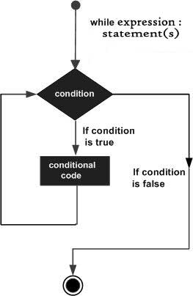
x = 17
while x>1:
x = x/2
Maybe we want to know how many steps that took:
x = 17
n = 0
while x>1:
x = x/2
n = n+1
- What is the answer?
- Can you get the same answer using import math and math.log(x,2) (and maybe round() or math.floor)?
- We can use logical operators to combine
x = 17
n = 0
while x>1 and n<3:
x = x/2
n = n+1

for loops
- what if we want to repeat a fixed number of times? We could use something like
n = 0
while n<n_max:
# do stuff
n = n+1
Or we could use a for loop:
for n in range(0,n_max):
# do stuff
- does this repeat n_max or n_max+1 times? (hint: try it out, and/or use list(range(...)) …)
- more generally, we can use for to iterate over any list.
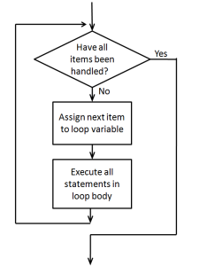
for loop

for loop examples
- CodingBat > string-2 > countHi
- CodingBat > string-2 > catDog
- CodingBat > Array-2 > bigDiff
Another example: a change-writing program.
Given an amount of money, return a list of length 5 that gives the (smallest) number of coins of each unit (toonies, loonies, quarters, dimes, and nickels) required to make up that amount.
total=5.73
toonies = 5.73 // 2 ## integer division
total = total - 2*toonies
total = 5.73
res = [] # empty list
denoms = list(2,1,0.25,0.1,0.05)
for d in denoms:
# do stuff
- start with total, use denoms above
- program to see how many pennies are left (how could we do this much more easily?)
- or print out change as we go along
- or save results as an array

Coin counting continued
Before coding up a solution, first describe it at a high level and then refine it:
- Initialization phase
  - initialize the variables that will be used, such as variables to hold the total amount of money, the list of coin denominations being used, and a list of the results.
- Loop. For each denomination d in our list:
  - determine how many coins of denomination d are needed.
  - update our result list with this amount.
  - update the total amount of money left.
- Print out the results

Prime walk
Now let’s look at the prime walk program again …
- Initialization phase
  - retrieve a list of primes
  - initialize the variables that will be used:
    - variables to hold the lists of the x and y coordinates of the points visited on the walk
    - the current direction of the walk
    - the number of steps taken on the walk so far
- Loop. For each step of the walk:
  - update the x and y coordinate lists with the coordinates of the next step
  - change the walk direction.
- display the walk.

More CodingBat examples:
- List-2 > count_evens
- List-2 >sum13
- List-2 > bigdiff
- reverse a list (not using slicing)?

break
break is a way to get out of a while or for loop early:
for i in range(0,10):
if i>5:
break

nested for loops
We can look at (e.g.) all the combinations of i and j via:
for i in range(0,3):
for j in range(0,3):
print([i,j])

matrix addition
We can store matrices as a list of lists: represents a 2 $×$ 3 matrix. We can loop over rows and columns to operate on every element, or combine the elements in some way:
## initialization
m = [[1,2,3], [2,7,9]]
nrows = len(m)
ncols = len(m[0])
total = 0
## loop
for i in range(nrows):
for j in range(ncols):
total += m[i][j]
print(total)
## 24

Loops and indices
From Secret Weblog: all of the following are equivalent …
i = 0
while i < mylist_length:
do_something(mylist[i])
i += 1 ## or i=i+1
vs.
for i in range(mylist_length):
do_something(mylist[i])
(this form is useful if we need to combine two lists, or otherwise index element i of several different things …)
vs.
for element in mylist:
do_something(element)

Criteria
- speed
- memory use
- simplicity (code length)
- simplicity (avoid modules)
- simplicity (avoid abstractions)
- pythonicity

