functions and debugging
Ben Bolker
23 September 2019

Functions
Reference: Python tutorial section 4.6
- the most important tool for structuring programs
- allows modularity
- basic definition: def function_name(args): plus indented code block
- inputs are called arguments. outputs are called return values
- when function is called, go to the function, with the arguments, run code until you hit return() (return None if you get to the end without a return)

return values
- most functions return values
- might not … side effects
  - input/output (create a plot, write output to a file, turn on a machine, …)
  - changing a (mutable!) variable

Function arguments
- basic arguments: unnamed, mandatory
- think of them as dummy variables; could be the same or different from the name in the calling environment

examples (try in Python tutor)
def add_one(x):
x = x+1
return(x)
x = 2
print("add_one=",add_one(x),", x=",x)
## add_one= 3 , x= 2
z = 2
print("add_one=",add_one(z),", z=",z)
## add_one= 3 , z= 2
z is immutable (a number), so it doesn’t change; if you want it to change, use z=add_one(z)

return()
The return() statement exits the function immediately.

mutability and functions
Changes within functions follow the standard mutability rules:
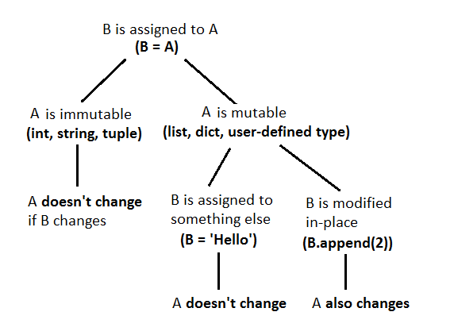
mutability mnemonic
Compare:
def no_return(x):
x = [2,3,4]
return(None)
z = [1,2,3]
no_return(z)
z
## [1, 2, 3]
None is a special word in Python.
With:
def no_return(x):
x[0] = 7
return(None)
z = [1,2,3]
no_return(z)
z
## [7, 2, 3]

optional arguments
- give default values
- for user convenience
- e.g. logarithm: def log(value,math.e)

Docstrings
- always say something about what your function does. (Feel free to give me a hard time in class if I don’t.)
def documented_function():
"""this is a function that does
nothing very useful
"""
return(None)

Example
def add_function(a, b):
""" the sum of two numbers
Parameters
----------
a : num
b : num
Returns
-------
sum : num
The sum of a and b
Examples
--------
>>> add_function(2, 5)
7
>>> add_function(3, -1.4)
1.6
"""
sum = a + b
return sum

retrieving docstring
print(add_function.__doc__)
## the sum of two numbers
## Parameters
## ----------
## a : num
## b : num
## Returns
## -------
## sum : num
## The sum of a and b
## Examples
## --------
## >>> add_function(2, 5)
## 7
## >>> add_function(3, -1.4)
## 1.6
##

Errors

Example code to work with

Types of errors
- syntax errors vs. logic errors
- a working matrix sum function
- failure modes from logic errors:
  - obvious failure
    - program stops with an error partway through: bad matrix sum #0
    - Python crashes
    - machine crashes
    - program never stops (infinite loop)
  - wrong answer
    - always vs. sometimes (obvious categories) vs. sometimes (mysterious)
    - obvious vs. subtle

Next section follows this presentation
- infinite loops:
What’s wrong with this code? (It’s meant to loop until the user enters either “y” or “n” …)
print("Please enter (y)es or (n)o")
cin = input()
while ((response != "y") or (response != "n")):
print("Please try again")
or (not response in "yn")
- bad matrix #1
- operator precedence mistakes, e.g. $Δfahrenheit=ΔCelsius×1.8$
fahrdiff = celsius_high - celsius_low * 1.8
- off-by-one error (“fencepost problem”)
- … more generally, edge or corner cases
- code incorrectly inside/outside loops:
- bad matrix #2
- bad matrix #3
- array index error (outside bounds)

Error messages
- error messages are trying to tell you something
- Google error messages (with quotation marks)

Debugging
- brute-force logic (“Feynman method”): stare at your code, try to figure out what’s wrong
(test cases: why is it failing in one specific situation?)
- flow charts, pseudocode
- tracing (print() statements)
  - put print statements before and after if conditions
  - before and after loops
  - in places where you suspect something might go wrong
- interactive tracing
- debugging tools (breakpoints/watchpoints/watches)

Searching for/asking for help

Searching for help
- Google (or your search engine of choice)
- be as specific as possible

Asking for help
- reproducible/minimal workable examples
  - right amount of context
  - “how to ask” (StackOverflow)
  - what have you tried? lmgtfy
- browse/lurk in forums first!
- tone
- where:
  - forums
  - StackOverflow

Testing
- Simplify, simplify, simplify
- Reduce the size of your problem
- Cases with easy/known answers
- “corner” & “edge” cases
- Random tests (fuzz testing)
- Automatic testing framework: nose
  - built-in Python package
  - define test file
    - basic: assert <condition>
    - extra: from nose.tools import assert_equal, assert_raises (or something)
    - (generating an error: raise ErrorType("message"), e.g. raise ValueError("non-conformable matrices")
    - each test or set of tests as a separate function
    - see test_mm.py
  - nosetests/run in PyCharm
- Test-driven development: write tests first!

Additional resources
- http://stackoverflow.com/questions/1623039/python-debugging-tips
- https://www.udacity.com/course/cs259
- http://www.cs.yale.edu/homes/aspnes/pinewiki/C%282f%29Debugging.html
- http://www.cs.cf.ac.uk/Dave/PERL/node149.html

