emerging infectious disease

30 Nov 2023

## emerging and re-emerging disease

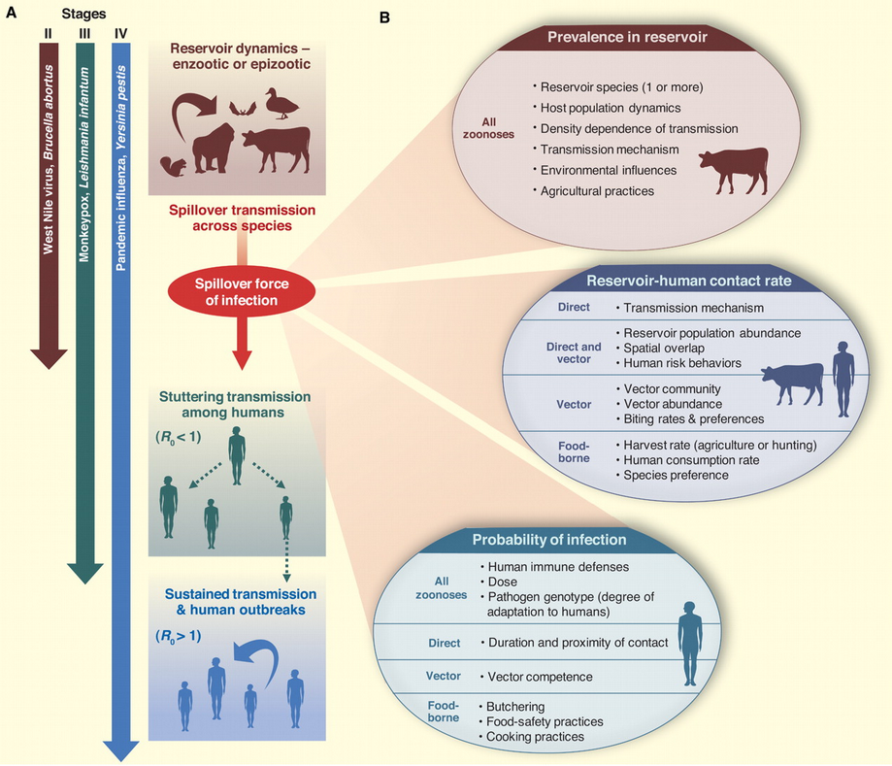

basically, anything we’re worried about

* encounter filter: changing patterns of reservoir host/vector distribution, human contact, …
* compatibility filter: changes via mutation, recombination, selection for resistance, …

Do we need to understand *everything*?

* reservoir ecology
* pathogen biology
* human-reservoir interactions

How do we understand? How do we predict?

## *Batrachochytrium dendrobatidis*

* fungal pathogen
  + most other chytrids are saprophytes, plant pathogens
  + *B. salamandrivorans*: salamander pathogen (more restricted)
* first discoved in poison dart frogs
* caused die-offs in E Australia, Central America, Colorado, California …
* association with high altitude?

Very confusing …

* declines occurred in pristine areas (probably not anthropogenic?)
* some species decline in the absence of Bd
* some species stable in the presence of Bd
* **tipping point hypothesis**: in populations all the time, but something happened to increase virulence/reduce tolerance or resistance ( $≈$ compatibility filter)
  + climate change/El Niño ?
  + ultraviolet radiation?
  + pesticides?
  + combination (species × temperature × U/V × pesticide × …)? (Pounds et al., 2006; Rohr et al., 2008; Rohr & Raffel, 2010)
* **novel pathogen hypothesis**: mutation/speciation + dispersal
  + detection in historical specimens: CA/bullfrog, Brazil …
  + genomics (challenging!)
  + Asian sampling

Fisher & Garner (2020)

## effects of climate change

* warming
  + ‘good’ or ‘bad’ for pathogens?
  + vector biology
    - extended range
    - higher activity?
    - e.g. Mordecai et al. (2020): shift from *Anopheles gambiae* to *Aedes aegypti*, malaria to arboviruses (dengue, chikungunya etc.)
* changes in seasonality, hydrological cycles
* local landscape change
  + hydrology
  + suburbanization and reforestation: Lyme disease
  + deforestation
    - MacDonald & Mordecai (2019): deforestation increases malaria, but malaria decreases deforestation
* changes in reservoir communities

## effects of biodiversity change: dilution effect (Keesing & Ostfeld, 2021)

* does increased biodiversity decrease disease?
* variation in reservoir competence
* high-quality hosts decrease with increasing biodiversity
  + encounter reduction; host regulation; vector preferences

Kain & Bolker (2019)

Rohr et al. (2020)

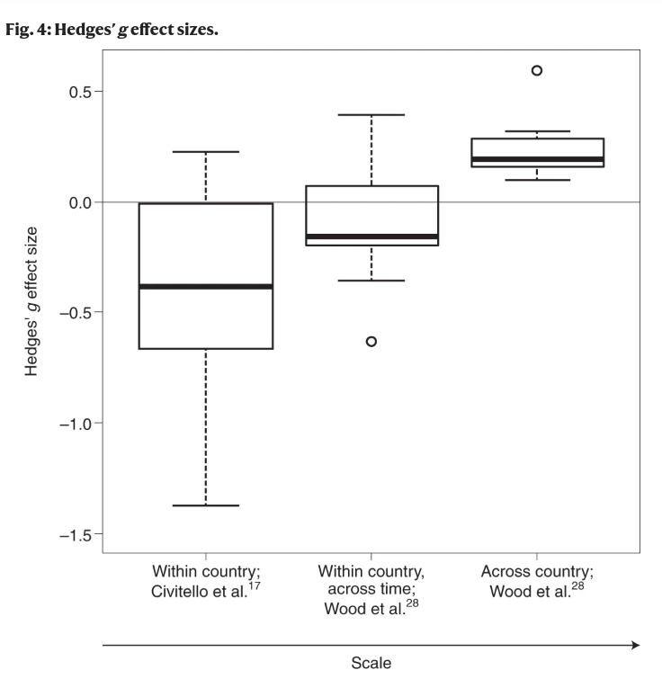

* Carlson et al. (2022): *higher* rodent diversity and climate anomalies drive plague spillover

## surveillance and prediction

* which viruses will emerge, where, why?

Pulliam & Dushoff (2009): predict zoonotic transmission of livestock viruses

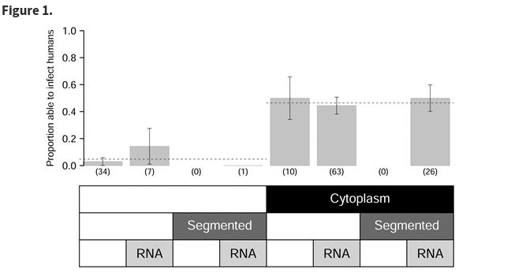

Walker et al. (2018): predict human transmission ability of zoonotic viruses

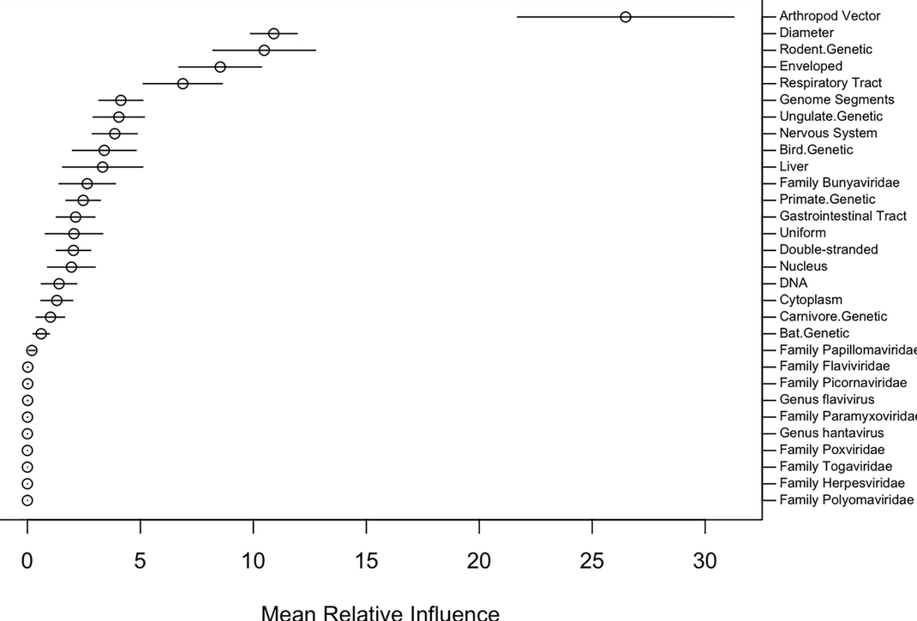

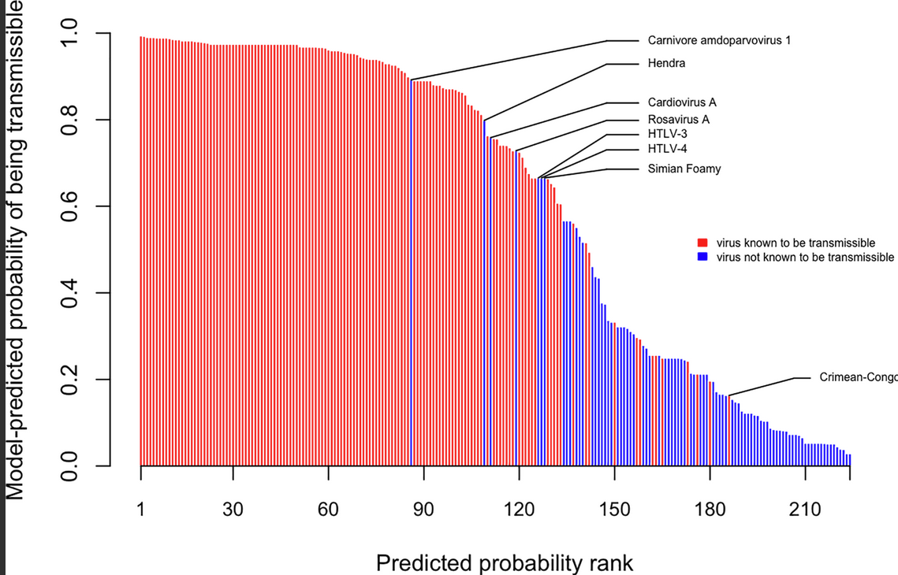

Han et al. (2020): model rodent life history

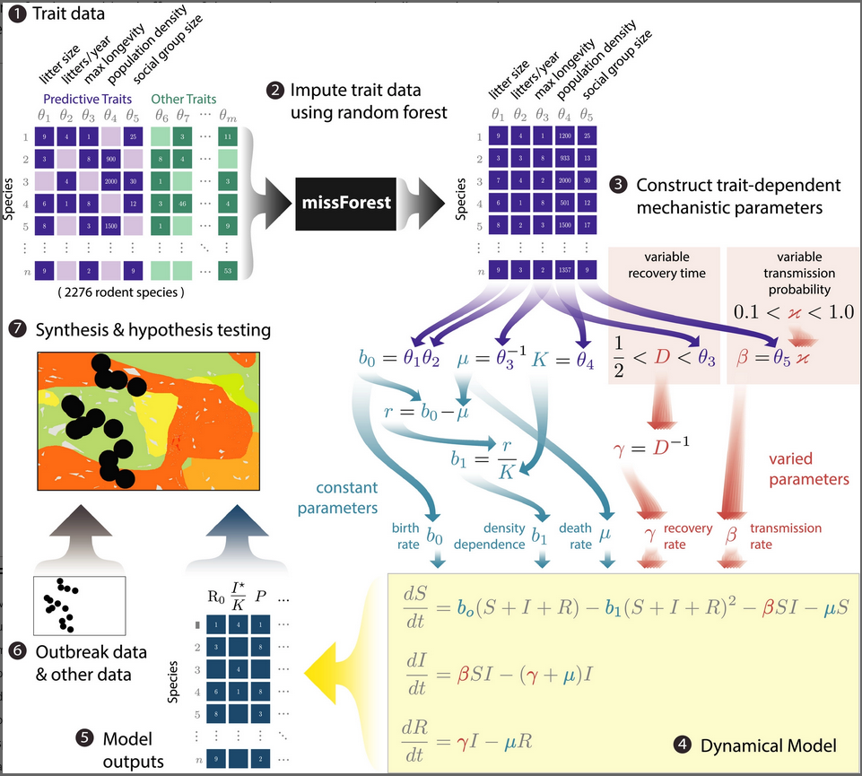

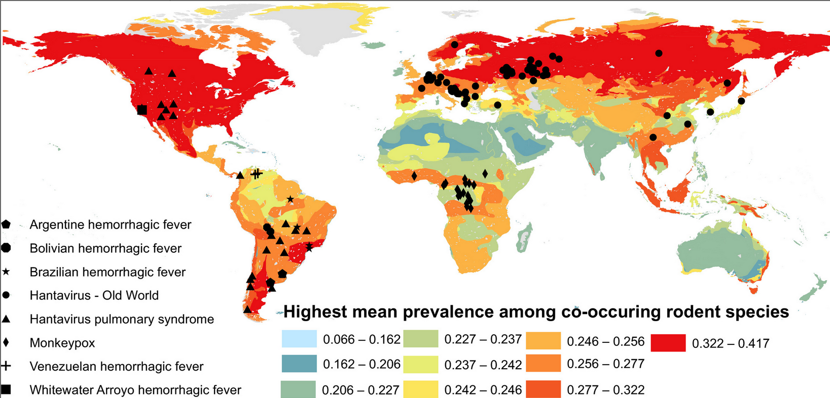

Evans et al. (2023): 2017-2020 sample: 12% of 693 individuals sampled in Myanmar were seropositive for sarbecovirus, more likely if they were loggers/hunters or had been exposed to bats …

## References

Carlson, C. J., Bevins, S. N., & Schmid, B. V. (2022). Plague risk in the western United States over seven decades of environmental change. *Global Change Biology*, *28*(3), 753–769. <https://doi.org/10.1111/gcb.15966>

Evans, T. S., Tan, C. W., Aung, O., Phyu, S., Lin, H., Coffey, L. L., Toe, A. T., Aung, P., Aung, T. H., Aung, N. T., Weiss, C. M., Thant, K. Z., Htun, Z. T., Murray, S., Wang, L.-F., Johnson, C. K., & Thu, H. M. (2023). Exposure to diverse sarbecoviruses indicates frequent zoonotic spillover in human communities interacting with wildlife. *International Journal of Infectious Diseases*, *0*(0). <https://doi.org/10.1016/j.ijid.2023.02.015>

Fisher, M. C., & Garner, T. W. J. (2020). Chytrid fungi and global amphibian declines. *Nature Reviews Microbiology*, *18*(6), 332–343. <https://doi.org/10.1038/s41579-020-0335-x>

Han, B. A., O’Regan, S. M., Paul Schmidt, J., & Drake, J. M. (2020). Integrating data mining and transmission theory in the ecology of infectious diseases. *Ecology Letters*, *23*(8), 1178–1188. <https://doi.org/10.1111/ele.13520>

Kain, M. P., & Bolker, B. M. (2019). Predicting West Nile virus transmission in North American bird communities using phylogenetic mixed effects models and eBird citizen science data. *Parasites & Vectors*, *12*(1), 395. <https://doi.org/10.1186/s13071-019-3656-8>

Keesing, F., & Ostfeld, R. S. (2021). Dilution effects in disease ecology. *Ecology Letters*, *24*(11), 2490–2505. <https://doi.org/10.1111/ele.13875>

MacDonald, A. J., & Mordecai, E. A. (2019). Amazon deforestation drives malaria transmission, and malaria burden reduces forest clearing. *Proceedings of the National Academy of Sciences*, *116*(44), 22212–22218. <https://doi.org/10.1073/pnas.1905315116>

Mordecai, E. A., Ryan, S. J., Caldwell, J. M., Shah, M. M., & LaBeaud, A. D. (2020). Climate change could shift disease burden from malaria to arboviruses in Africa. *The Lancet Planetary Health*, *4*(9), e416–e423. <https://doi.org/10.1016/S2542-5196(20)30178-9>

Pounds, A. J., Bustamante, M. R., Coloma, L. A., Consuegra, J. A., Fogden, M. P. L., Foster, P. N., La Marca, E., Masters, K. L., Merino-Viteri, A., Puschendorf, R., Ron, S. R., Sánchez-Azofeifa, G. A., Still, C. J., & Young, B. E. (2006). Widespread amphibian extinctions from epidemic disease driven by global warming. *Nature*, *439*(7073), 161–167. <https://doi.org/10.1038/nature04246>

Pulliam, J. R. C., & Dushoff, J. (2009). Ability to Replicate in the Cytoplasm Predicts Zoonotic Transmission of Livestock Viruses. *The Journal of Infectious Diseases*, *199*(4), 565–568. <https://doi.org/10.1086/596510>

Rohr, J. R., Civitello, D. J., Halliday, F. W., Hudson, P. J., Lafferty, K. D., Wood, C. L., & Mordecai, E. A. (2020). Towards common ground in the biodiversity–disease debate. *Nature Ecology & Evolution*, *4*(1), 24–33. <https://doi.org/10.1038/s41559-019-1060-6>

Rohr, J. R., & Raffel, T. R. (2010). Linking global climate and temperature variability to widespread amphibian declines putatively caused by disease. *Proceedings of the National Academy of Sciences*, *107*(18), 8269–8274. <https://doi.org/10.1073/pnas.0912883107>

Rohr, J. R., Raffel, T. R., Romansic, J. M., McCallum, H., & Hudson, P. J. (2008). Evaluating the links between climate, disease spread, and amphibian declines. *Proceedings of the National Academy of Sciences*, *105*(45), 17436–17441. <https://doi.org/10.1073/pnas.0806368105>

Walker, J. W., Han, B. A., Ott, I. M., & Drake, J. M. (2018). Transmissibility of emerging viral zoonoses. *PLOS ONE*, *13*(11), e0206926. <https://doi.org/10.1371/journal.pone.0206926>

Last updated: 2023-11-30 12:19:33.558089