evolution of host resistance and tolerance

28 October 2023

# Definitions/questions

* **resistance**: host’s ability to resist or minimize infection
* **tolerance**: host’s ability to support parasite infection without losing fitness
* **competence**: host’s ability to support *and transmit* parasites (especially vector-borne)
* encounter and compatibility filters: avoiding parasites vs killing vs tolerating them

## Mechanisms

* active defense (*plastic* or *facultative* defenses): **recognition systems** and **effectors**
  + recognition systems are the *qualitative* component of host defense: does the host recognize that the parasite (specifically, a parasite **antigen**) is present? These will typically evolve by Red Queen dynamics (i.e., via an inverse matching allele model). In vertebrates: **antibodies**
  + must be **specific** (self/non-self recognition), trigger proportionate response
  + coded by the **major histocompatibility complex** (self/non-self recognition), **somatic recombination**, deletion of host-specific antigens (Borghans, Beltman, and De Boer 2004; Acevedo-Whitehouse and Cunningham 2006; Rauch, Kalbe, and Reusch 2006; Spurgin and Richardson 2010)
  + *effectors*: what does the host do once the parasite is detected?
* passive/always-on defense: **constitutive**
  + changing cell surface receptors (e.g. CCR5- $Δ32$ (HIV, Hummel et al. (2005)); matching-allele model
* parasite countermeasures (immune evasion [trypanosomes], immune suppression [measles, anthrax, …]) (Schmid-Hempel 2009)

## Costs and tradeoffs

What are the **costs** of resistance and tolerance? (= Why aren’t all hosts tolerant/resistant to all parasites?)

(Klemme, Hyvärinen, and Karvonen 2020)

* cost of maintaining recognition mechanisms
* cost of choosing different habitats
* tradeoffs (RQ-related or ?)

## Population-level evolution (eco-evolution)

Stahl et al. (1999); Roy and Kirchner (2000)

* resistance lowers prevalence - selects against itself; expect *polymorphism*
* tolerance increases prevalence - selects for itself (*apparent competition* with non-tolerant genotypes); expect *fixation*. (Is tolerance evolution-proof? (Schneider and Ayres 2008))

## Measuring quantitative resistance/tolerance

* tolerance: loss of fitness **per unit parasite load**
* resistance: level of parasite load

(Raberg, Sim, and Read 2007; Råberg, Graham, and Read 2009)

|  |  |
| --- | --- |
| ! |  |

## Disentangling the history/origin of deleterious recessive Mendelian alleles

* Genetic *polymorphisms* are interesting; why haven’t they been eliminated or fixed?

## hypotheses

* genetic drift (null)
  + historic size of populations? (historical records, population genetics [*coalescents*])
  + strength of selection/maintenance in large populations?
* heterozygote advantage
* frequency-dependent selection (RQ vs. arms race)

## Tay-Sachs disease

* Lethal abnormality in hexosaminidase A (lipid metabolism); early (infant/toddler) death
* Mendelian, recessive lethal ($s=1$)
* allele frequency $≈$ 1/300 in US population, 1/30 in Ashkenazi (E. European) Jews: also high in French Canadians, Cajuns, Pennsylvania Dutch …
* Population-genetic evidence suggests drift
* (Terrible!) speculation about **overdominance** or **heterozygote advantage**: Tb resistance, intelligence: ???  
  (Spyropoulos 1988; Frost 2012; Frisch et al. 2004)

## phenylketonuria (PKU)

* metabolic disorder (phenylalanine)
* many different mutations
* homozygous PKU historically lethal (**selection coefficient** = 1)
* PKU alleles are old

## PKU incidence (Hillert et al. 2020)

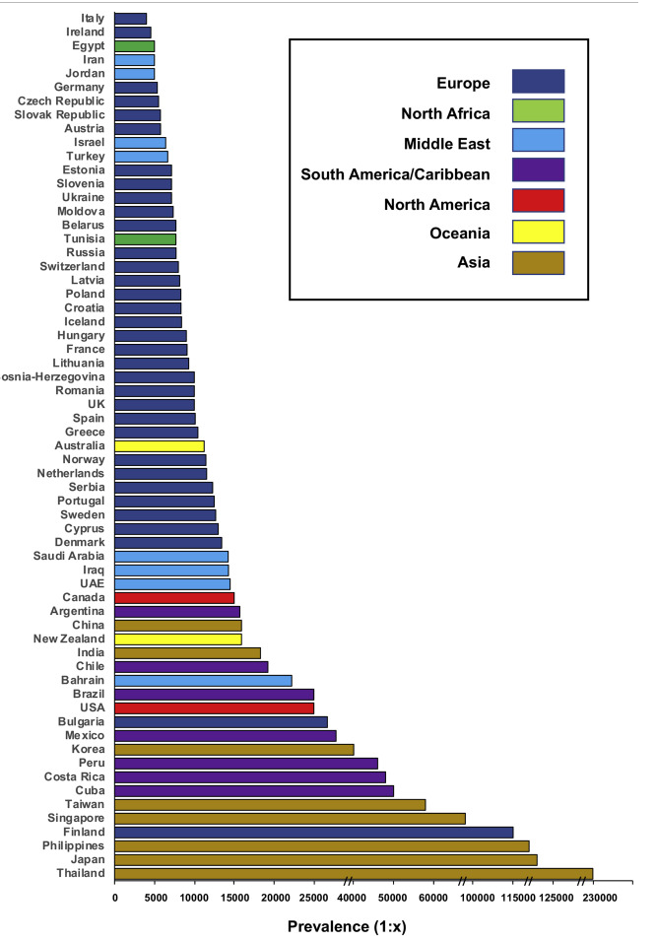

## PKU genetics

why not drift? (Krawczak and Zschocke 2003)

* many different mutations
* present across many populations
* populations without history of being small
  + e.g. Irish gene pool from $≈$ 2500 BC
  + population size was 100K-200K
  + current expected frequency 0.6% is twice as high as expected

## PKU genetics: conclusion

* calculation from genetic models
* heterozygote advantage probably $≈$ 1.5%
* hard to measure directly!
* probably due to higher phenylalanine levels in heterozygotes
* phenotypic effects?
  + higher birth weight
  + mycotoxin resistance?
  + starvation resistance?

## Sickle-cell

* overdominance  
  (heterozygote advantage)
* selection for *falciparum* malaria resistance
* geographic patterns;  
  consistency with malaria distribution Esoh and Wonkam (2021)
* mechanistic basis for protection
* evidence for positive selection (age??)

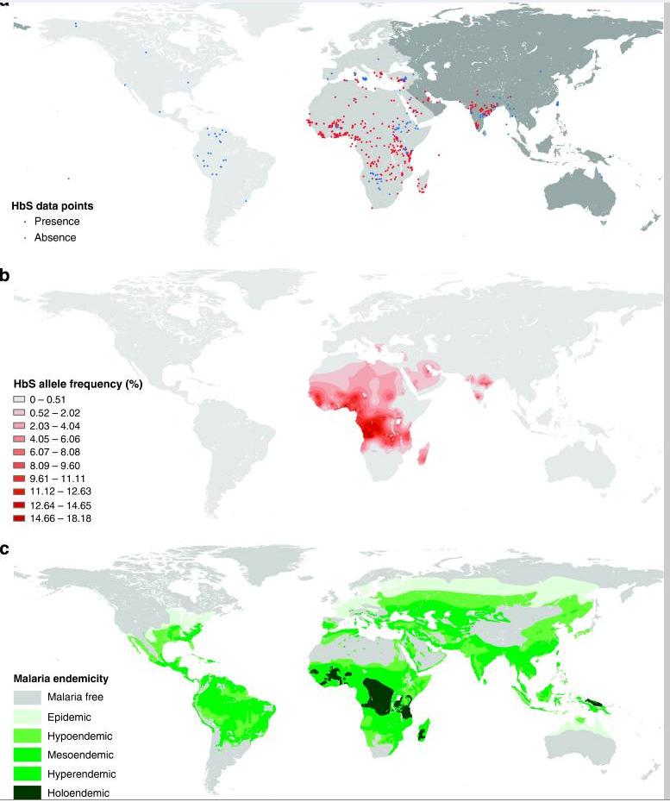

## Balanced polymorphisms

* Sickle-cell (and all cases of overdominance) depends on genetic makeup of the *population*
* chance of mating with a carrier is higher when allele is more common
* easier to do the math at the level of alleles

## Selective sweeps

* strong selection on an allele
* individuals carrying that allele have high fitness
* lower (gene-specific) **effective population size**
* neighbouring loci carried along as **haplotypes**: **hitchhiking**
* haplotypes gradually erode (narrow) by recombination
* e.g. MHC class I variability in chimpanzees decreased ~ 2-3 mya (Groot et al. 2002)

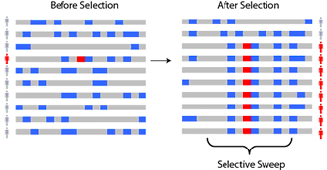

## Selective sweep: chromosome pattern

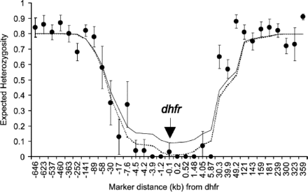

(Nair et al. 2003)

## Other malaria-protective variation

* hemoglobin variants:
  + blood groups, Rh-negativity  
    (older than malaria)
  + thalassemia
* enzyme variants:
  + GP6D deficiency/favism
    - Mediterranean populations
    - X-linked
    - arose 5-10K years ago: agriculture?
* Duffy antigens (protection against *vivax* malaria)

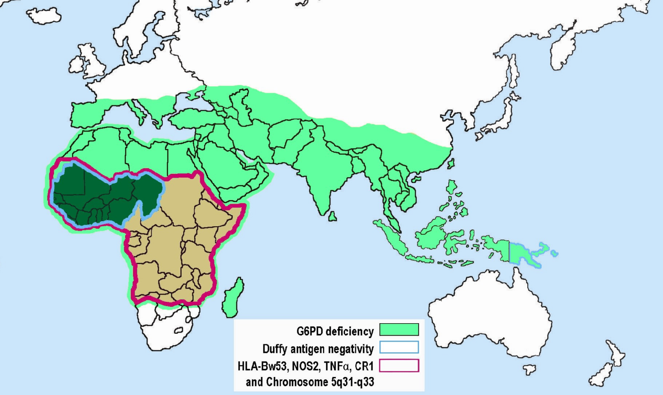

[Wikipedia](https://en.wikipedia.org/wiki/Genetic_resistance_to_malaria)

## Cystic fibrosis

* Lethal lung disease: mucus build-up  
  (1/4 chance of death before 30, previously much higher)
* 4% carriers in European whites (1/2500 diseased: $2pq=0.04→q^{2}=0.0004$)
* Mutated cftr gene, changes chloride metabolism;  
  age approx. 50 KYA
* Protection from cholera? (First European cholera epidemic 1817) Dehydrating intestinal diseases? Typhoid?
* **Pleiotropy** (multiple effects from one gene)

## HIV

From Galvani and Novembre (2005):

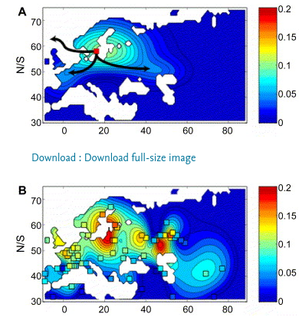

* where does CCR5- $Δ32$ come from?
* homozygous individuals are healthy …
* at least 5000 years old; Hummel et al. (2005); Novembre, Galvani, and Slatkin (2005); Galvani and Novembre (2005); Lidén, Linderholm, and Götherström (2006)
  + “If $Δ32$ were neutral, population genetics theory predicts it would have to be much older given its frequency.”
* high dispersal, sustained strong selection ($s>0.1$); what selective agent? plague? smallpox?

## Summary: variation in Mendelian traits

* (relatively) simple inheritance
  + recessive/dominant, autosomal/X/Y-linked
* mechanisms
  + drift
  + heterozygote advantage
  + balancing selection/tradeoffs; gene × environment interaction
* evidence
  + ancient DNA
  + phylogenetic patterns/*coalescent* methods to estimate origin times/places
  + biogeography/history of disease/environment
  + mechanism
  + population history

## more examples

Domínguez-Andrés and Netea (2019)

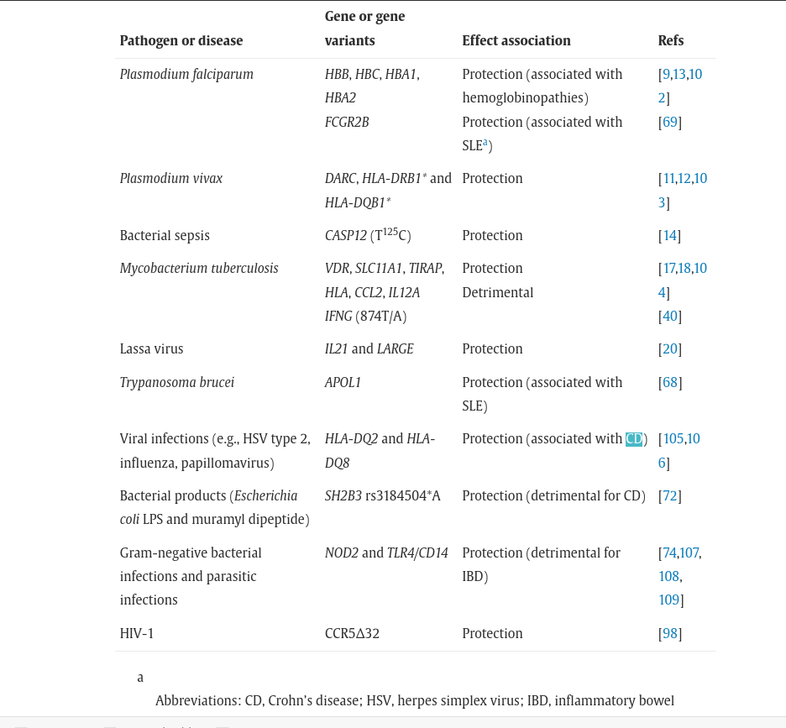

## GWAS

Mboowa et al. (2018)

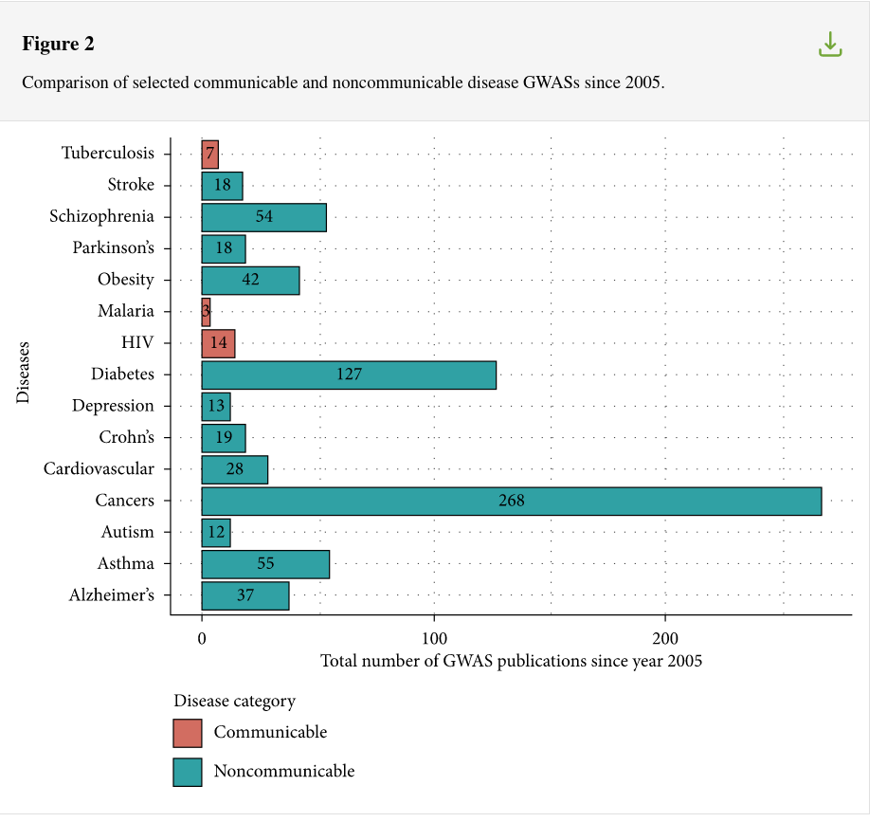

## References

Acevedo-Whitehouse, K., and A. A Cunningham. 2006. “Is MHC Enough for Understanding Wildlife Immunogenetics?” *Trends in Ecology & Evolution* 21 (8): 433–38.

Borghans, J. A. M, J. B Beltman, and R. J De Boer. 2004. “MHC Polymorphism Under Host-Pathogen Coevolution.” *Immunogenetics* 55 (11): 732–39.

Domínguez-Andrés, Jorge, and Mihai G. Netea. 2019. “Impact of Historic Migrations and Evolutionary Processes on Human Immunity.” *Trends in Immunology* 40 (12): 1105–19. <https://doi.org/10.1016/j.it.2019.10.001>.

Esoh, Kevin, and Ambroise Wonkam. 2021. “Evolutionary History of Sickle-Cell Mutation: Implications for Global Genetic Medicine.” *Human Molecular Genetics* 30 (R1): R119–28. <https://doi.org/10.1093/hmg/ddab004>.

Frisch, Amos, Roberto Colombo, Elena Michaelovsky, Mazal Karpati, Boleslaw Goldman, and Leah Peleg. 2004. “Origin and Spread of the 1278insTATC Mutation Causing Tay-Sachs Disease in Ashkenazi Jews: Genetic Drift as a Robust and Parsimonious Hypothesis.” *Human Genetics* 114 (4): 366–76. <https://doi.org/10.1007/s00439-003-1072-8>.

Frost, Peter. 2012. “Tay-Sachs and French Canadians: A Case of Gene-Culture Co-Evolution?” *Advances in Anthropology* 02 (03): 132–38. <https://doi.org/10.4236/aa.2012.23016>.

Galvani, Alison P., and John Novembre. 2005. “The Evolutionary History of the CCR5- $Δ32$ HIV-Resistance Mutation.” *Microbes and Infection* 7 (2): 302–9. <https://doi.org/10.1016/j.micinf.2004.12.006>.

Groot, Natasja G. de, Nel Otting, Gaby G. M. Doxiadis, Sunita S. Balla-Jhagjhoorsingh, Jonathan L. Heeney, Jon J. van Rood, Pascal Gagneux, and Ronald E. Bontrop. 2002. “Evidence for an Ancient Selective Sweep in the MHC Class I Gene Repertoire of Chimpanzees.” *Proceedings of the National Academy of Sciences* 99 (18): 11748–53. <https://doi.org/10.1073/pnas.182420799>.

Hillert, Alicia, Yair Anikster, Amaya Belanger-Quintana, Alberto Burlina, Barbara K. Burton, Carla Carducci, Ana E. Chiesa, et al. 2020. “The Genetic Landscape and Epidemiology of Phenylketonuria.” *The American Journal of Human Genetics* 107 (2): 234–50. <https://doi.org/10.1016/j.ajhg.2020.06.006>.

Hummel, S., D. Schmidt, B. Kremeyer, B. Herrmann, and M. Oppermann. 2005. “Detection of the CCR5- $Δ32$ HIV Resistance Gene in Bronze Age Skeletons.” *Genes & Immunity* 6 (4): 371–74. <https://doi.org/10.1038/sj.gene.6364172>.

Klemme, Ines, Pekka Hyvärinen, and Anssi Karvonen. 2020. “Negative Associations Between Parasite Avoidance, Resistance and Tolerance Predict Host Health in Salmonid Fish Populations.” *Proceedings of the Royal Society B: Biological Sciences* 287 (1925): 20200388. <https://doi.org/10.1098/rspb.2020.0388>.

Krawczak, Michael, and Johannes Zschocke. 2003. “A Role for Overdominant Selection in Phenylketonuria? Evidence from Molecular Data.” *Human Mutation* 21 (4): 394–97. <https://doi.org/10.1002/humu.10205>.

Lidén, Kerstin, Anna Linderholm, and Anders Götherström. 2006. “Pushing It Back. Dating the CCR5–32 Bp Deletion to the Mesolithic in Sweden and Its Implications for the Meso\Neo Transition.” *Documenta Praehistorica* 33 (December): 29–37. <https://doi.org/10.4312/dp.33.5>.

Mboowa, Gerald, Ivan Sserwadda, Marion Amujal, and Norah Namatovu. 2018. “Human Genomic Loci Important in Common Infectious Diseases: Role of High-Throughput Sequencing and Genome-Wide Association Studies.” *Canadian Journal of Infectious Diseases and Medical Microbiology* 2018 (March): e1875217. <https://doi.org/10.1155/2018/1875217>.

Nair, Shalini, Jeff T. Williams, Alan Brockman, Lucy Paiphun, Mayfong Mayxay, Paul N. Newton, Jean-Paul Guthmann, et al. 2003. “A Selective Sweep Driven by Pyrimethamine Treatment in Southeast Asian Malaria Parasites.” *Molecular Biology and Evolution* 20 (9): 1526–36. <https://doi.org/10.1093/molbev/msg162>.

Novembre, John, Alison P. Galvani, and Montgomery Slatkin. 2005. “The Geographic Spread of the CCR5 $Δ32$ HIV-Resistance Allele.” *PLOS Biology* 3 (11): e339. <https://doi.org/10.1371/journal.pbio.0030339>.

Piel, Frédéric B., Anand P. Patil, Rosalind E. Howes, Oscar A. Nyangiri, Peter W. Gething, Thomas N. Williams, David J. Weatherall, and Simon I. Hay. 2010. “Global Distribution of the Sickle Cell Gene and Geographical Confirmation of the Malaria Hypothesis.” *Nature Communications* 1 (November): 104. <https://doi.org/10.1038/ncomms1104>.

Raberg, Lars, Derek Sim, and Andrew F. Read. 2007. “Disentangling Genetic Variation for Resistance and Tolerance to Infectious Diseases in Animals.” *Science* 318 (5851): 812–14. <https://doi.org/10.1126/science.1148526>.

Råberg, Lars, Andrea L Graham, and Andrew F Read. 2009. “Decomposing Health: Tolerance and Resistance to Parasites in Animals.” *Philosophical Transactions of the Royal Society B: Biological Sciences* 364 (1513): 37–49. <https://doi.org/10.1098/rstb.2008.0184>.

Rauch, G., M. Kalbe, and T. B. H Reusch. 2006. “Relative Importance of MHC and Genetic Background for Parasite Load in a Field Experiment.” *Evolutionary Ecology Research* 8 (2): 373–86.

Roy, B. A., and J. W. Kirchner. 2000. “Evolutionary Dynamics of Pathogen Resistance and Tolerance.” *Evolution* 54 (1): 51–63. <https://doi.org/10.1111/j.0014-3820.2000.tb00007.x>.

Schmid-Hempel, Paul. 2009. “Immune Defence, Parasite Evasion Strategies and Their Relevance for ‘Macroscopic Phenomena’ Such as Virulence.” *Philosophical Transactions of the Royal Society B: Biological Sciences* 364 (1513): 85–98. <https://doi.org/10.1098/rstb.2008.0157>.

Schneider, David S., and Janelle S. Ayres. 2008. “Two Ways to Survive Infection: What Resistance and Tolerance Can Teach Us about Treating Infectious Diseases.” *Nature Reviews Immunology* 8 (11): 889–95. <https://doi.org/10.1038/nri2432>.

Spurgin, Lewis G., and David S. Richardson. 2010. “How Pathogens Drive Genetic Diversity: MHC, Mechanisms and Misunderstandings.” *Proceedings of the Royal Society B: Biological Sciences* 277 (1684): 979–88. <https://doi.org/10.1098/rspb.2009.2084>.

Spyropoulos, B. 1988. “Tay-Sachs Carriers and Tuberculosis Resistance.” *Nature* 331 (6158): 666. <https://doi.org/10.1038/331666a0>.

Stahl, Eli A., Greg Dwyer, Rodney Mauricio, Martin Kreitman, and Joy Bergelson. 1999. “Dynamics of Disease Resistance Polymorphism at the Rpm1 Locus of Arabidopsis.” *Nature* 400 (6745): 667–71. <https://doi.org/10.1038/23260>.

Last updated: 2023-10-30 12:17:57.472741