evolution of parasite countermeasures

6 Nov 2023

# General principles

* two stages of evolution: *de novo* mutation and selection
* limiting factors in *de novo* mutation
  + mutation rate (per locus/per genome)
  + population size
  + generation time
  + rate appearance of new mutations = (mutation rate × pop size)/(generation time)
  + mutational **spectrum**: what can mutations achieve?
* limiting factors in selection:
  + selection differential
    - benefits (= prob of encountering antibiotic × benefit of resistance)
    - costs [metabolic/energetic; reduced efficiency]
      * **compensatory** mutations (reduce cost)
  + pop size (drift vs selection; bottlenecks in between-host transmission)
  + variation in selection (within- vs between-host)
  + recombination and/or horizontal transmission via mobile elements (plasmids etc.)
* competition between susceptible and resistant strains (Lipsitch & Samore, 2002)

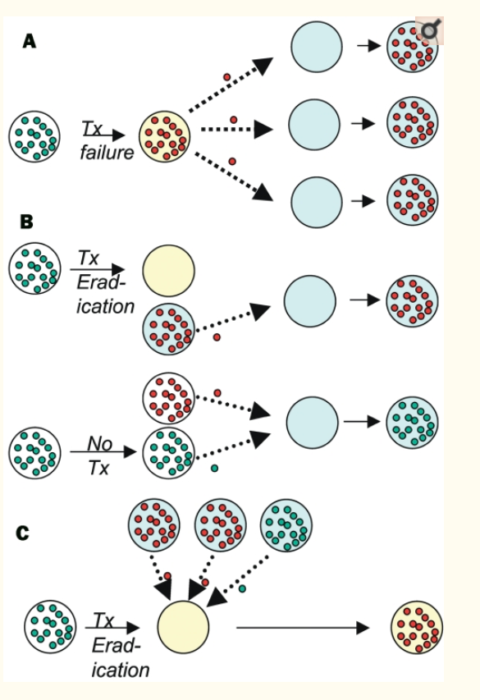 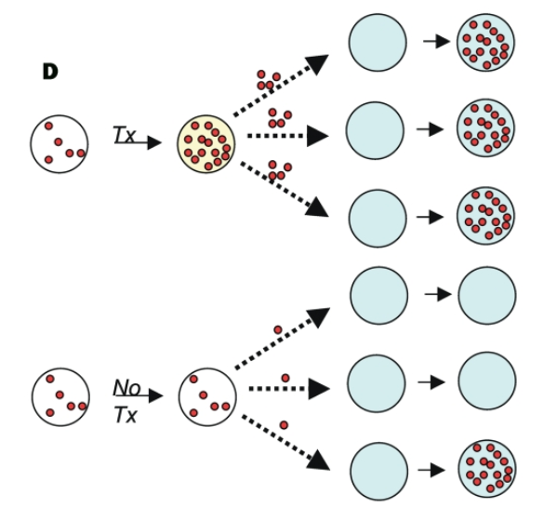

1. resistant bacteria take over during treatment failure (within-host competition)
2. resistant bacteria take advantage of reduced transmission by treated hosts (between-host)
3. resistant bacteria colonize a treated host (empty patch)
4. resistant bacteria take advantage of side effects (bystander effects)

# Bacteria

## Mechanisms

* because bacteria and animals are biochemically different, can use substances that disrupt bacterial but not animal metabolic processes
* many biologically derived
  + fungi (penicillin!) (Karwehl & Stadler, 2016)
  + soil bacteria (esp *Streptomyces*; streptomycin, tetracycline)
  + (also chemical/synthetic, e.g. derived from dyes - *sulfa drugs*)
* because antibiotics have been around “forever”, so has antibiotic resistance (D’Costa et al., 2011)
  + but presence **as mobile elements** may be recent, human/animal derived (Ebmeyer et al., 2021)
  + often present in antibiotic *producers* (Benveniste & Davies, 1973)
* huge problem, e.g. mdrMRSA ([multi-drug resistant], methicillin-resistant *Staphylococcus aureus*), extensively drug-resistant (XDR) tuberculosis (Centers for Disease Control, 2020)
  + threatens to wipe out disease cures …
* horizontal transfer is rampant
  + resistance gene can be anywhere in the microbiome …
  + **collateral** or **non-target selection** (Llewelyn et al., 2017)
  + also makes it easier to lose resistance when no longer required
  + thus resistance is usually/often pre-existing
* mechanisms of action:
  + pumps (“efflux system”: remove toxic substances from the cell)
  + inactivation or degradation/detoxification
  + altered pathways?
* antibiotics are *effectors* (not recognizers)
* cost of resistance; are resistance alleles lost or compensated in the absence of antibiotics? (Bjorkholm et al., 2001; Levin et al., 2000)

## Implications for antibiotic use

* avoid overuse! “antibiotic conservation”
* regulate agricultural use
  + for human-to-human transmission, regulating agriculture may be too late once resistance is already established in humans (Smith et al., 2002)
* 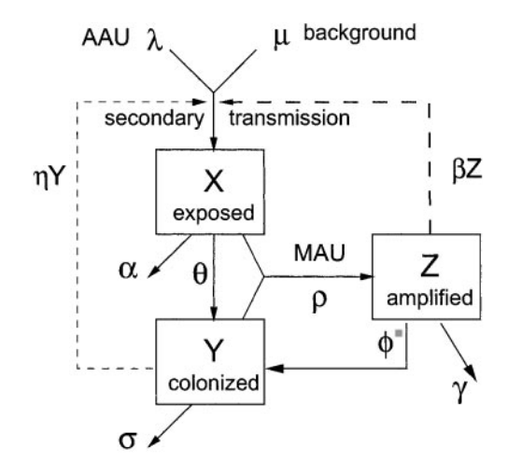
  + but regulation still helps with spillover infections (Lipsitch et al., 2002)
* “the long-term benefit of single drug treatment from introduction of the antibiotic until a high frequency of resistance precludes its use is almost independent of the pattern of antibiotic use” (Bonhoeffer, Lipsitch, et al., 1997)
* “cocktails” may be best; varying treatments in space is better than cycling (Bergstrom et al., 2004)
* treating for longer increases collateral selection (Llewelyn et al., 2017)
* contrast: Tb (chronic disease, resistance from point mutations)

# Viruses

* similar biochemistry to hosts
  + often fought by priming immune system, i.e. *vaccination*
  + resistance via **recognition escape** rather than disabling effectors
  + usually **strain replacement** rather than within-lineage selection on escape alleles
    - horizontal transfer/lineage-mixing does happen via recombination (especially influenza, phages), but less typical (Mavrich & Hatfull, 2017; Wu et al., 2023)
* very high mutation rate
  + *de novo* mutation is a bigger problem
* HIV
  + single-drug resistance evolves quickly (Bonhoeffer, Coffin, et al., 1997)
  + target non-host-like biochemistry: nucleoside and non-nucleoside resistance transcriptase inhibitors; protease, integrase inhibitors
  + HAART (Eggleton & Nagalli, 2022); e.g. standard South African regimen includes tenofovir, lamivudine (nucleotide analog), dolutegravir (integrase inhibitor) (South Africa National Department of Health, 2019)
  + keeping load low reduces transmission *and* within-host evolution of resistance
  + between-host transmission maybe less important because of early infectivity
* strain replacement
  + COVID-19! alpha, delta, omicron (Ferguson et al., 2021)
  + influenza, every year (*antigenic drift*)/pandemic (*antigenic shift*)
  + other examples: *Haemophilus influenzae B* (Adam et al., 2010)
  + human papilloma virus: maybe not? (Covert et al., 2019; Man et al., 2021)
  + **not**: smallpox (gone), rinderpest, chickenpox, measles, rubella
  + importance of focusing on **conserved** viral **epitopes**; universal flu vaccine? (Wang et al., 2022) (back to the *mutational spectrum*)
* back to bacteria: vaccine-preventable *Bordetella pertussis*, resurgence and evolution of immune evasion (?) (van Gent et al., 2012)

(**to be added, maybe**)

## malaria control

[Twitter](https://twitter.com/ProfDavidLSmith/status/1504110201875562504):

reading various malaria documents that discuss having endemic malaria today despite spending ~$4.1B/yr, I always want to insert the comment, “Well, WTF did you expect? No one who understands malaria believes elimination would be possible without spending at least $10B/yr”

Main components:

* antimalarial drugs
* vaccine (children only, max effectiveness $≈$ 40%, safety concerns …) (Jarry, 2021; Seo et al., 2014)
* vector control
  + indoor residual spraying (lethality + avoidance)
  + treated bednets (lethality + avoidance)
  + biocontrol (e.g. *Gambusia*, “mosquito fish”)
  + improved housing? (Musiime et al., 2022)

## malaria resistance to antimalarial drugs

* protozoan parasite
* quinine, chloroquine (Achan et al., 2011; Ashley et al., 2014)
* artemisinin (and combination therapy, ACT)

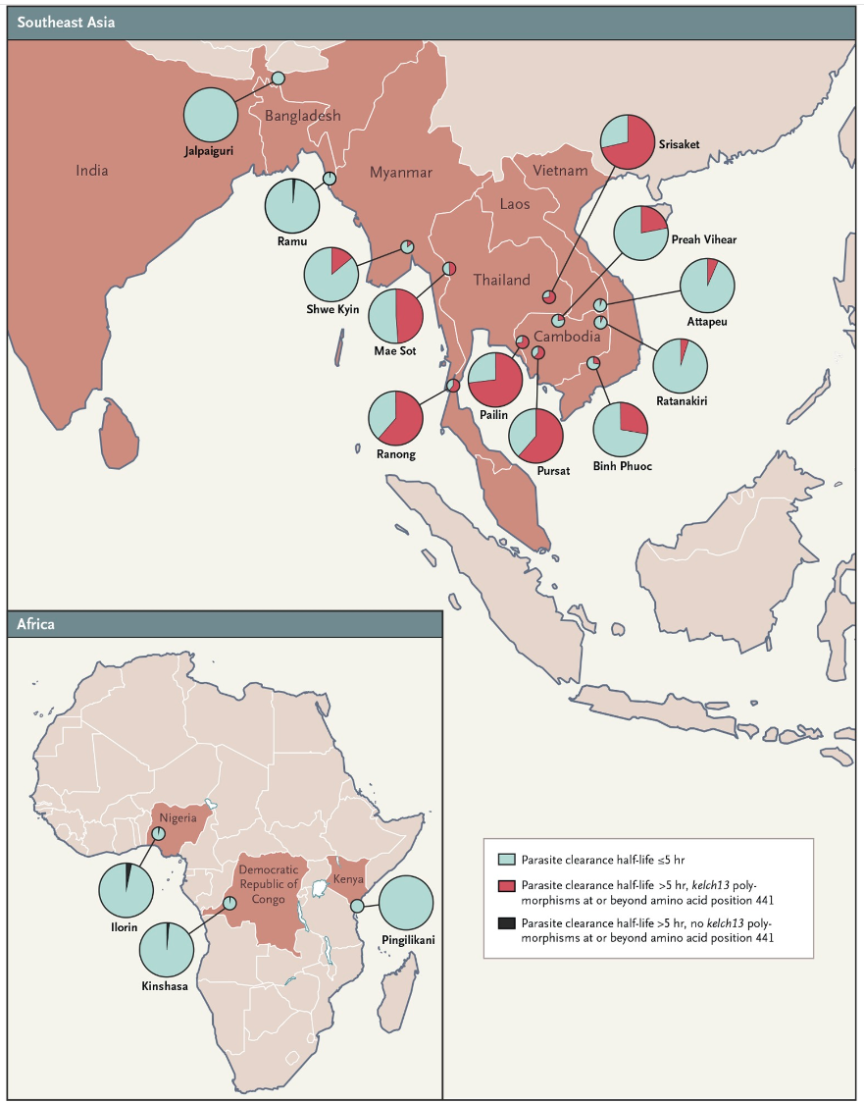

From Ashley et al. (2014)

Rosenthal (2021): “Recent data suggest that we are on the verge of clinically meaningful artemisinin-resistance in Africa”

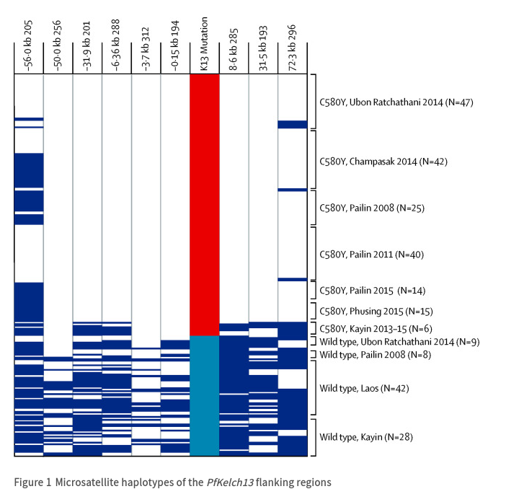

From Imwong et al. (2017). Red box=C580Y. Light blue box=wild type. Each row represents one parasite isolate; white cells indicate identical microsatellite alleles compared with the most frequent allele and dark blue cells indicate differences. containment strategies: eliminate *falciparum* malaria from Greater Mekong region or “firewall”?

## vectors and resistance to insecticides

* DDT [Wikipedia](https://en.wikipedia.org/wiki/DDT#Mosquito_resistance)
  + environmental side effects
    - fast evolution of resistance: 6-7 years (Gladwell, 2001)
* other methods?
  + sterile male release (irradiation, *Wolbachia*) (Atyame et al., 2016)
  + **gene drive** (Burt et al., 2018) and/or bacterial infection (Dennison et al., 2014)
    - reduce vector competence
    - shift sex ratios toward males
  + evolution-resistant insecticides: shorten host life span (Koella et al., 2009; McMeniman et al., 2009)
    - weak selection against late-acting processes (Medawar, 2019)
    - late-acting insecticides (W. or fungal)
    - larvicides: resistant phenotypes are smaller/short-lived

## References

Achan, J., Talisuna, A. O., Erhart, A., Yeka, A., Tibenderana, J. K., Baliraine, F. N., Rosenthal, P. J., & D’Alessandro, U. (2011). Quinine, an old anti-malarial drug in a modern world: Role in the treatment of malaria. *Malaria Journal*, *10*(1), 144. <https://doi.org/10.1186/1475-2875-10-144>

Adam, H. J., Richardson, S. E., Jamieson, F. B., Rawte, P., Low, D. E., & Fisman, D. N. (2010). Changing epidemiology of invasive Haemophilus influenzae in Ontario, Canada: Evidence for herd effects and strain replacement due to Hib vaccination. *Vaccine*, *28*(24), 4073–4078. <https://doi.org/10.1016/j.vaccine.2010.03.075>

Ashley, E. A., Dhorda, M., Fairhurst, R. M., Amaratunga, C., Lim, P., Suon, S., Sreng, S., Anderson, J. M., Mao, S., Sam, B., Sopha, C., Chuor, C. M., Nguon, C., Sovannaroth, S., Pukrittayakamee, S., Jittamala, P., Chotivanich, K., Chutasmit, K., Suchatsoonthorn, C., … White, N. J. (2014). Spread of Artemisinin Resistance in Plasmodium falciparum Malaria. *New England Journal of Medicine*, *371*(5), 411–423. <https://doi.org/10.1056/NEJMoa1314981>

Atyame, C. M., Labbé, P., Lebon, C., Weill, M., Moretti, R., Marini, F., Gouagna, L. C., Calvitti, M., & Tortosa, P. (2016). Comparison of irradiation and Wolbachia based approaches for sterile-male strategies targeting *Aedes albopictus*. *PLOS ONE*, *11*(1), e0146834. <https://doi.org/10.1371/journal.pone.0146834>

Benveniste, R., & Davies, J. (1973). Aminoglycoside Antibiotic-Inactivating Enzymes in Actinomycetes Similar to Those Present in Clinical Isolates of Antibiotic-Resistant Bacteria. *Proceedings of the National Academy of Sciences*, *70*(8), 2276–2280. <https://doi.org/10.1073/pnas.70.8.2276>

Bergstrom, C. T., Lo, M., & Lipsitch, M. (2004). Ecological theory suggests that antimicrobial cycling will not reduce antimicrobial resistance in hospitals. *Proceedings of the National Academy of Sciences*, *101*(36), 13285–13290. <https://doi.org/10.1073/pnas.0402298101>

Bjorkholm, B., Sjölund, M., Falk, P. G., Berg, O. G., Engstrand, L., & Andersson, D. I. (2001). Mutation frequency and biological cost of antibiotic resistance in Helicobacter pylori. *Proceedings of the National Academy of Sciences of the United States of America*, *98*(25), 14607–14612. <https://doi.org/10.1073/pnas.241517298>

Bonhoeffer, S., Coffin, J. M., & Nowak, M. A. (1997). Human immunodeficiency virus drug therapy and virus load. *Journal of Virology*, *71*(4), 3275–3278. <http://www.ncbi.nlm.nih.gov/pmc/articles/PMC191463/>

Bonhoeffer, S., Lipsitch, M., & Levin, B. R. (1997). Evaluating treatment protocols to prevent antibiotic resistance. *Proceedings of the National Academy of Sciences*, *94*(22), 12106–12111. <https://doi.org/10.1073/pnas.94.22.12106>

Burt, A., Coulibaly, M., Crisanti, A., Diabate, A., & Kayondo, J. K. (2018). Gene drive to reduce malaria transmission in sub-Saharan Africa. *Journal of Responsible Innovation*, *5*(sup1), S66–S80. <https://doi.org/10.1080/23299460.2017.1419410>

Centers for Disease Control. (2020). *Extensively Drug-Resistant Tuberculosis (XDR TB)*. <https://www.cdc.gov/tb/publications/factsheets/drtb/xdrtb.htm>

Covert, C., Ding, L., Brown, D., Franco, E. L., Bernstein, D. I., & Kahn, J. A. (2019). Evidence for cross-protection but not type-replacement over the 11 years after human papillomavirus vaccine introduction. *Human Vaccines & Immunotherapeutics*.

D’Costa, V. M., King, C. E., Kalan, L., Morar, M., Sung, W. W. L., Schwarz, C., Froese, D., Zazula, G., Calmels, F., Debruyne, R., Golding, G. B., Poinar, H. N., & Wright, G. D. (2011). Antibiotic resistance is ancient. *Nature*, *477*(7365), 457–461. <https://doi.org/10.1038/nature10388>

Dennison, N. J., Jupatanakul, N., & Dimopoulos, G. (2014). The mosquito microbiota influences vector competence for human pathogens. *Current Opinion in Insect Science*, *3*, 6–13. <https://doi.org/10.1016/j.cois.2014.07.004>

Ebmeyer, S., Kristiansson, E., & Larsson, D. G. J. (2021). A framework for identifying the recent origins of mobile antibiotic resistance genes. *Communications Biology*, *4*(1), 1–10. <https://doi.org/10.1038/s42003-020-01545-5>

Eggleton, J. S., & Nagalli, S. (2022). Highly Active Antiretroviral Therapy (HAART). In *StatPearls*. StatPearls Publishing. <http://www.ncbi.nlm.nih.gov/books/NBK554533/>

Ferguson, N., Ghani, A., Cori, A., Hogan, A., Hinsley, W., & Volz, E. (2021). Report 49 - Growth, population distribution and immune escape of Omicron in England. In *Imperial College London*. <http://www.imperial.ac.uk/medicine/departments/school-public-health/infectious-disease-epidemiology/mrc-global-infectious-disease-analysis/covid-19/report-49-omicron/>

Gladwell, M. (2001). The Mosquito Killer. *The New Yorker*. <https://web.archive.org/web/20160416165010/http://gladwell.com/the-mosquito-killer/>

Imwong, M., Suwannasin, K., Kunasol, C., Sutawong, K., Mayxay, M., Rekol, H., Smithuis, F. M., Hlaing, T. M., Tun, K. M., Pluijm, R. W. van der, Tripura, R., Miotto, O., Menard, D., Dhorda, M., Day, N. P. J., White, N. J., & Dondorp, A. M. (2017). The spread of artemisinin-resistant Plasmodium falciparum in the Greater Mekong subregion: A molecular epidemiology observational study. *The Lancet Infectious Diseases*, *17*(5), 491–497. <https://doi.org/10.1016/S1473-3099(17)30048-8>

Jarry, J. (2021). The Malaria Vaccine’s Success Story Hides Legitimate Concerns. In *McGill University Office for Science and Society*. <https://www.mcgill.ca/oss/article/health-and-nutrition/malaria-vaccines-success-story-hides-legitimate-concerns>

Karwehl, S., & Stadler, M. (2016). Exploitation of Fungal Biodiversity for Discovery of Novel Antibiotics. In M. Stadler & P. Dersch (Eds.), *How to Overcome the Antibiotic Crisis : Facts, Challenges, Technologies and Future Perspectives* (pp. 303–338). Springer International Publishing. <https://doi.org/10.1007/82_2016_496>

Koella, J. C., Lynch, P. A., Thomas, M. B., & Read, A. F. (2009). Towards evolution-proof malaria control with insecticides. *Evolutionary Applications*, *2*(4), 469–480. <https://doi.org/10.1111/j.1752-4571.2009.00072.x>

Levin, B. R., Perrot, V., & Walker, N. (2000). Compensatory mutations, antibiotic resistance and the population genetics of adaptive evolution in bacteria. *Genetics*, *154*(3), 985–997.

Lipsitch, M., & Samore, M. H. (2002). Antimicrobial Use and Antimicrobial Resistance: A Population Perspective. *Emerging Infectious Diseases*, *8*(4), 347–354. <https://doi.org/10.3201/eid0804.010312>

Lipsitch, M., Singer, R. S., & Levin, B. R. (2002). Antibiotics in agriculture: When is it time to close the barn door? *Proceedings of the National Academy of Sciences of the United States of America*, *99*(9), 5752–5754. <https://doi.org/10.1073/pnas.092142499>

Llewelyn, M. J., Fitzpatrick, J. M., Darwin, E., SarahTonkin-Crine, Gorton, C., Paul, J., Peto, T. E. A., Yardley, L., Hopkins, S., & Walker, A. S. (2017). The antibiotic course has had its day. *BMJ*, *358*, j3418. <https://doi.org/10.1136/bmj.j3418>

Man, I., Vänskä, S., Lehtinen, M., & Bogaards, J. A. (2021). Human papillomavirus genotype replacement: Still too early to tell? *The Journal of Infectious Diseases*, *224*(3), 481–491.

Mavrich, T. N., & Hatfull, G. F. (2017). Bacteriophage evolution differs by host, lifestyle and genome. *Nature Microbiology*, *2*, 17112. <https://doi.org/10.1038/nmicrobiol.2017.112>

McMeniman, C. J., Lane, R. V., Cass, B. N., Fong, A. W. C., Sidhu, M., Wang, Y.-F., & O’Neill, S. L. (2009). Stable introduction of a life-shortening Wolbachia infection into the mosquito *Aedes aegypti*. *Science*, *323*(5910), 141–144. <https://doi.org/10.1126/science.1165326>

Medawar, P. B. (2019). *The Uniqueness of the Individual*. Routledge. <https://doi.org/10.4324/9780429299759>

Musiime, A. K., Krezanoski, P. J., Smith, D. L., Kilama, M., Conrad, M. D., Otto, G., Kyagamba, P., Asiimwe, J., Rek, J., Nankabirwa, J. I., Arinaitwe, E., Akol, A. M., Kamya, M. R., Staedke, S. G., Drakeley, C., Bousema, T., Lindsay, S. W., Dorsey, G., & Tusting, L. S. (2022). House design and risk of malaria, acute respiratory infection and gastrointestinal illness in Uganda: A cohort study. *PLOS Global Public Health*, *2*(3), e0000063. <https://doi.org/10.1371/journal.pgph.0000063>

Rosenthal, P. J. (2021). Has artemisinin resistance emerged in Africa? *The Lancet Infectious Diseases*, *21*(8), 1056–1057. <https://doi.org/10.1016/S1473-3099(21)00168-7>

Seo, M. K., Baker, P., & Ngo, K. N.-L. (2014). Cost-effectiveness analysis of vaccinating children in Malawi with RTS,S vaccines in comparison with long-lasting insecticide-treated nets. *Malaria Journal*, *13*(1), 66. <https://doi.org/10.1186/1475-2875-13-66>

Smith, D. L., Harris, A. D., Johnson, J. A., Silbergeld, E. K., & Morris, J. G. (2002). Animal antibiotic use has an early but important impact on the emergence of antibiotic resistance in human commensal bacteria. *Proceedings of the National Academy of Sciences of the United States of America*, *99*(9), 6434–6439. <https://doi.org/10.1073/pnas.082188899>

South Africa National Department of Health, R. of. (2019). *2019 ART Clinical Guidelines for the Management of HIV in Adults, Pregnancy, Adolescents, Children, Infants and Neonates*. <https://www.nicd.ac.za/wp-content/uploads/2019/11/2019-ART-Clinical-Guidelines-25-Nov.pdf>

van Gent, M., Bart, M. J., van der Heide, H. G. J., Heuvelman, K. J., & Mooi, F. R. (2012). Small Mutations in *Bordetella pertussis* Are Associated with Selective Sweeps. *PLOS ONE*, *7*(9), e46407. <https://doi.org/10.1371/journal.pone.0046407>

Wang, W.-C., Sayedahmed, E. E., Sambhara, S., & Mittal, S. K. (2022). Progress towards the Development of a Universal Influenza Vaccine. *Viruses*, *14*(8), 1684. <https://doi.org/10.3390/v14081684>

Wu, J., Meng, L., Gaïa, M., Hikida, H., Okazaki, Y., Endo, H., & Ogata, H. (2023). *Gene transfer among viruses substantially contributes to gene gain of giant viruses* (p. 2023.09.26.559659). bioRxiv. <https://doi.org/10.1101/2023.09.26.559659>

Last updated: 2023-11-26 16:37:09.072017