Parasites and host communities

Parasites can have large effects on their host populations and communities; can

* determine the competitive balance between two species, whether one species can invade or coexist with another;
* change the flow of energy through and relative balance of different trophic levels;
* act as “ecosystem engineers” to change the environment in which other organisms live;
* have cascading effects on entire ecosystems, determining their biomass or diversity.

## Indirect interactions

* **Direct** interactions among species: (e.g.) parasites change the fecundity and mortality of their hosts, leading to population cycles.
* **Indirect interactions**: the direct (-/+) interaction between parasites and one host leads to a change in the interaction between two hosts, or between one host and another species in the community. These interactions can be **density-mediated** (parasite changes the population density of the target host, benefiting the second species indirectly) or **trait-mediated** (parasite changes behavior of its host, which hurts or helps another species).
* Direct effects between deer, moose, and parasite populations:  
  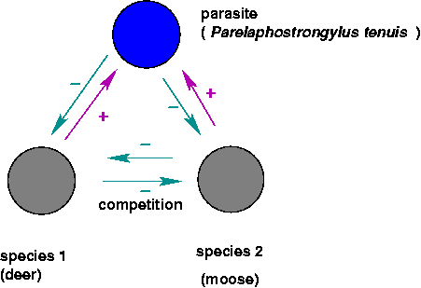
* The indirect interactions:  
  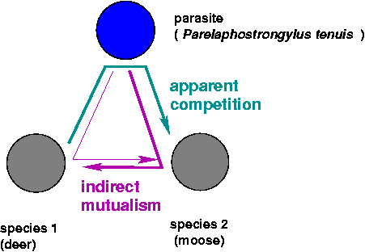
* Indirect effects: a parasite that changes the behavior of its host to encourage trophic transmission:  
  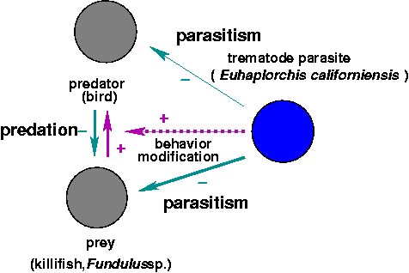

K. D. Lafferty (2008)

Costs and benefits of parasitism: individual-level vs. population-level effects.

## Parasite-mediated coexistence (Combes 1996)

* *Drosophila melanogaster*, *D. simulans*, *L. boulardi* (parasitoid wasp): exclusion by *melanogaster* in absence of *boulardi*; coexistence in presence of *boulardi*; exclusion by *simulans* at lower temperature with *boulardi* (Combes 1996)
* *Tribolium castaneum*, *T. confusum* (flour beetles), *Adelina tribolii* (sporozoan parasite) (Park 1948)
* Prevention of mixing because hybrids are less resistant to parasites? (**outbreeding depression**)

## Parasite-mediated invasion

* human movement: Europeans to the New World, Europeans to Africa
* introduced parasites: e.g. *Acipenser stellatus* (from Caspian to Aral Sea), carried *Nitzchia sturionis* (gill monogenean), severely reduced populations of *A. nudiventris*
* Invasive species and the **natural enemy hypothesis** (green crabs: Torchin, Lafferty, and Kuris (2001))
* lots more examples: Strauss, White, and Boots (2012)]

## Parasite-mediated resistance to invasion

* *Parelaphostrongylus tenuis* (meningeal worm): kills moose (*Alces alces*) and caribou (*Rangifer tarandus*) in clinical infections (brain pathology), doesn’t kill white-tailed deer. Moose density inversely correlated with density of *P. tenuis* eggs in deer feces.

*P. tenuis* has a two-host life cycle, from gastropods which are eaten accidentally by grazing ungulates and back again (via excreted eggs which hatch into larvae and bore into the gastropods when they crawl over the larvae).

In the absence of the worm, moose can outcompete white-tailed deer for forage. Has *P. tenuis* has caused the rise of deer and the decline of moose in the southern boreal forest? Do deer and *P. tenuis* prevent the reintroduction of moose?

Schmitz and Nudds (1994): macroparasite model with two possible definitive hosts, moose and deer, which also compete with each other. *P. tenuis* kills moose, no effect on deer. Model suggests that (depending on parameters that we don’t know), moose could outcompete deer, be outcompeted by deer, or coexist even in the presence of deer and *P. tenuis*.

* just because a parasite kills a host in a clinical setting doesn’t mean that the parasite will necessary reduce host population significantly
* model identifies sensitive parameters:
  + growth rate of intermediate hosts (gastropods)
  + competitive interaction between moose and deer
  + death rate of moose from parasites

## Trophic cascades and apparent mutualism

* **Trophic cascades**: alternating changes in density at odd vs. even a food chain (prey decrease, prey’s prey increase, etc.). Can parasites be “top predators” in these cases?
* Cestodes/killifish/seabirds: whether this helps or hurts the predator (individual or population) depends on level of parasitism, costs, benefits. Predator population size might be max. with no parasites, but individual decisions (presumably) maximize individual fitness.
* Toxoplasma-induced bottom-up trophic cascades (??): Skorping and Högstedt (2001)/Pusenius and Ostfeld (2000): *more* seeds eaten in the presence of stoats than in their absence!)
* Increased flow through food webs, ecosystem efficiency?

## ecosystem engineering

* Parasitized cockles (F. Thomas and Poulin 1998; Frédéric Thomas et al. 1999): changed bioturbation (stirring), presence of hard surface has various impacts on community structure. Changes habitat for other species; “arrows” (influence of one species on another) mediated through the environment.

## Large-scale community structure

* rinderpest $→$ ungulates $→$ grass $→$ brushy vegetation $→$ tsetse flies $→$ trypanosomiasis: keeps out livestock, horses (and hence humans, or at least Europeans) (Pearce 2000)
* Serengeti
  + rinderpest, ungulates, vegetation, trypanosome interaction (Pearce 2000)
  + Holdo et al. (2009): effects of rinderpest on fire frequency and carbon storage

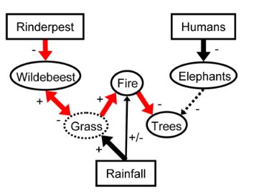

* Chestnut blight (hypovirulence, fungal superparasites)
* Cascading effects of myxomatosis in Australia and Britain (Sumption and Flowerdew 1985)
  + Britain: post 1954-55, increased woodland regeneration and increased grassland and cereal production - increase in many inverts, voles, but some species of insects declined (Large Blue Butterfly, *Maculinea arion*, went extinct because of missing red ant species) - predator populations dropped immediately, but generalists recovered - other rabbit parasites declined

## Community effects on parasites

* “Keeping the herds healthy”: when is predator removal bad for hosts?
* Packer et al. (2003), Kevin D. Lafferty (2004)
* competing effects
  + kill infected individuals, reduce density
  + *inverse* density dependence (e.g. vector-borne transmission)?

In general, predator removal is more likely to be harmful [i.e. increase parasitism] when the parasite is highly virulent, macroparasites are highly aggregated in their prey, hosts are long-lived and the predators select infected prey

* Richards, Drake, and Ezenwa (2021)

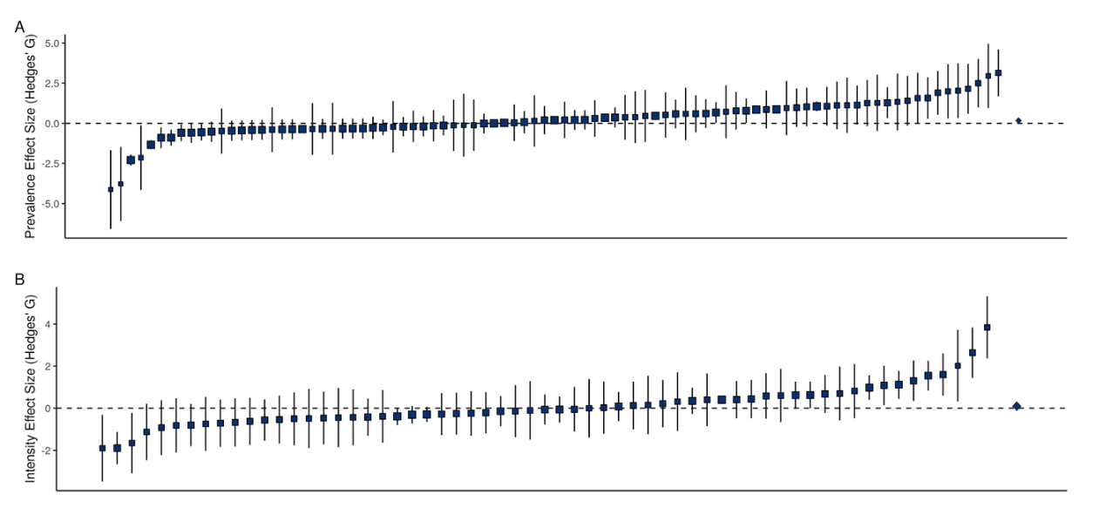

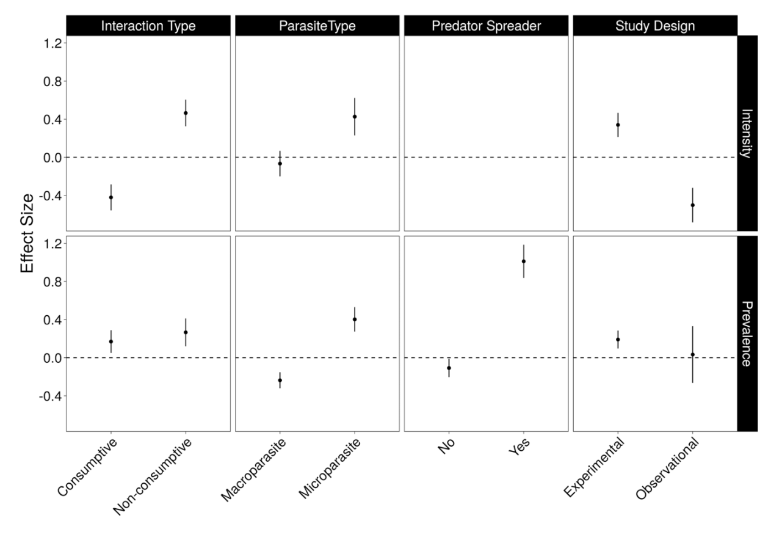

## References

Combes, Claude. 1996. “Parasites, Biodiversity and Ecosystem Stability.” *Biodiversity & Conservation* 5 (8): 953–62. <https://doi.org/10.1007/BF00054413>.

Holdo, Ricardo M., Anthony R. E. Sinclair, Andrew P. Dobson, Kristine L. Metzger, Benjamin M. Bolker, Mark E. Ritchie, and Robert D. Holt. 2009. “A Disease-Mediated Trophic Cascade in the Serengeti and Its Implications for Ecosystem C.” *PLoS Biol* 7 (9): e1000210. <https://doi.org/10.1371/journal.pbio.1000210>.

Lafferty, K. D. 2008. “Ecosystem Consequences of Fish Parasites.” *Journal of Fish Biology* 73 (9): 2083–93. <https://doi.org/10.1111/j.1095-8649.2008.02059.x>.

Lafferty, Kevin D. 2004. “Fishing for Lobsters Indirectly Increases Epidemics in Sea Urchins.” *Ecological Applications* 14 (5): 1566–73. <https://doi.org/10.1890/03-5088>.

Packer, Craig, Robert D. Holt, Peter J. Hudson, Kevin D. Lafferty, and Andrew P. Dobson. 2003. “Keeping the Herds Healthy and Alert: Implications of Predator Control for Infectious Disease.” *Ecology Letters* 6 (9): 797–802. <https://doi.org/10.1046/j.1461-0248.2003.00500.x>.

Park, Thomas. 1948. “Interspecies Competition in Populations of Trilobium Confusum Duval and Trilobium Castaneum Herbst.” *Ecological Monographs* 18 (2): 265–307. <https://doi.org/10.2307/1948641>.

Pearce, Fred. 2000. “Inventing Africa.” *New Scientist* 167 (2251): 30. <http://www.faculty.umb.edu/pjt/pearce00.pdf>.

Pusenius, Jyrki, and Richard S. Ostfeld. 2000. “Effects of Stoat’s Presence and Auditory Cues Indicating Its Presence on Tree Seedling Predation by Meadow Voles.” *Oikos* 91 (1): 123–30. <https://doi.org/10.1034/j.1600-0706.2000.910111.x>.

Richards, Robert L., John M. Drake, and Vanessa O. Ezenwa. 2021. “Do Predators Keep Prey Healthy or Make Them Sicker? A Meta-Analysis.” *Ecology Letters* 25 (2). <https://doi.org/10.1111/ele.13919>.

Schmitz, Oswald J., and Thomas D. Nudds. 1994. “Parasite-Mediated Competition in Deer and Moose: How Strong Is the Effect of Meningeal Worm on Moose?” *Ecological Applications* 4 (1): 91–103. <https://doi.org/10.2307/1942118>.

Skorping, Arne, and Göran Högstedt. 2001. “Trophic Cascades: A Role for Parasites?” *Oikos* 94 (1): 191–92. <https://doi.org/10.1034/j.1600-0706.2001.t01-1-11193.x>.

Strauss, Alex, Andy White, and Mike Boots. 2012. “Invading with Biological Weapons: The Importance of Disease-Mediated Invasions.” *Functional Ecology* 26 (6): 1249–61. <https://doi.org/10.1111/1365-2435.12011>.

Sumption, K. J., and J. R. Flowerdew. 1985. “The Ecological Effects of the Decline in Rabbits (Oryctolagus Cuniculus L.) Due to Myxomatosis.” *Mammal Review* 15 (4): 151–86. <https://doi.org/10.1111/j.1365-2907.1985.tb00396.x>.

Thomas, F., and R. Poulin. 1998. “Manipulation of a Mollusc by a Trophically Transmitted Parasite: Convergent Evolution or Phylogenetic Inheritance?” *Parasitology* 116 (5): 431–36. <https://doi.org/10.1017/S003118209800239X>.

Thomas, Frédéric, Robert Poulin, Thierry de Meeüs, Jean-François Guégan, François Renaud, Frederic Thomas, Thierry de Meeus, Jean-Francois Guegan, and Francois Renaud. 1999. “Parasites and Ecosystem Engineering: What Roles Could They Play?” *Oikos* 84 (1): 167. <https://doi.org/10.2307/3546879>.

Torchin, Mark E., Kevin D. Lafferty, and Armand M. Kuris. 2001. “Release from Parasites as Natural Enemies: Increased Performance of a Globally Introduced Marine Crab.” *Biological Invasions* 3 (4): 333–45. <https://doi.org/10.1023/A:1015855019360>.

Last updated: 2023-10-15 16:00:44.269943