Within-host dynamics

Understanding within-host host-parasite interactions (focus on dynamics)
Lots of molecular biology, genetics (recognition mechanisms and effector mechanisms), won’t deal with that now.
Interaction between different components of the immune system (modeled at different levels of detail/realism), parasite populations (maybe in multiple compartments?)
Longitudinal data (relatively rare), distributional data.

HIV dynamics under (ineffective) treatment
Bonhoeffer, Coffin, and Nowak (1997)
- Early HIV antivirals: relatively ineffective due to rapid mutation
- Large decline in virus loads (up to 300-fold decline in viral RNA in some patients)
- but no clearance
- within-host $R_{0}≈50$
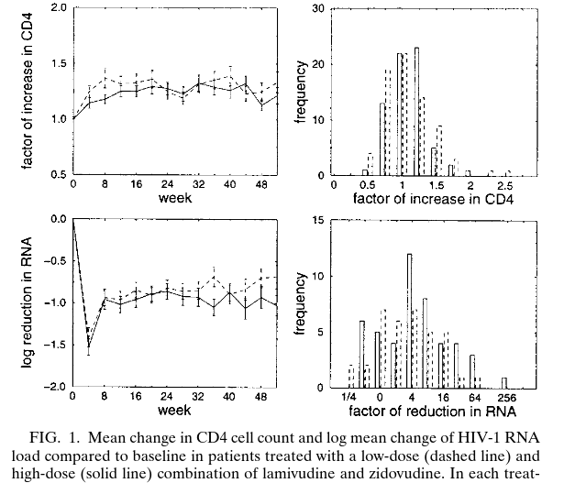
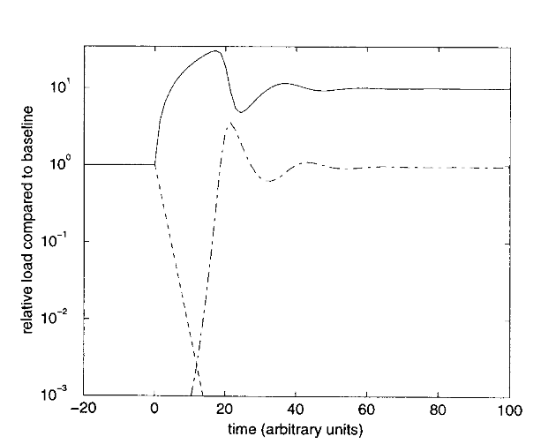
- “virus load paradox”: if $R_{0}$ is initially 50, we would have to reduce it to slightly above 1 but never below 1 to see these results.
$$\begin{matrix}\frac{dC}{dt} & =λ−μC−βCV \\ \frac{dV}{dt} & =βCV−aV\end{matrix}$$
- add a drug-resistant type to the model
- add mutation (and back-mutation) to the model
- add immune responses ($dz/dt=kV−γz$)
- homeostasis of infectible cells (logistic growth)
- virus-induced killing of uninfected cells (e.g. gp120 shedding)
- differential effects of drug on different types
- distribution of infectibility
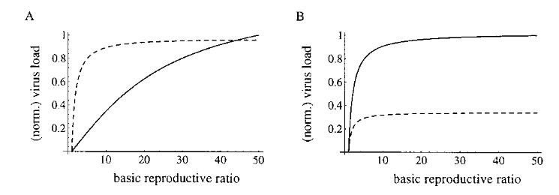

Within-host (and within-cell) dynamics of salmonella
- intracellular bacterium
Brown et al. (2006)
- model:
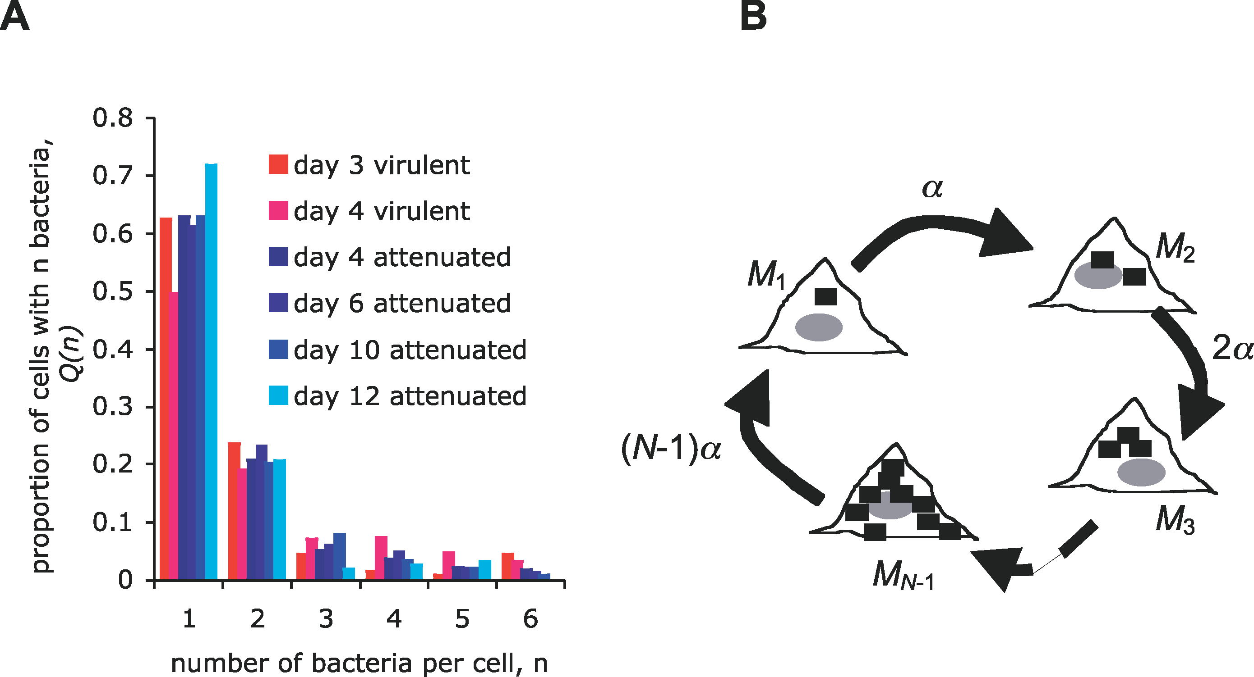
- assume that host cells are always available (infinite $S$)
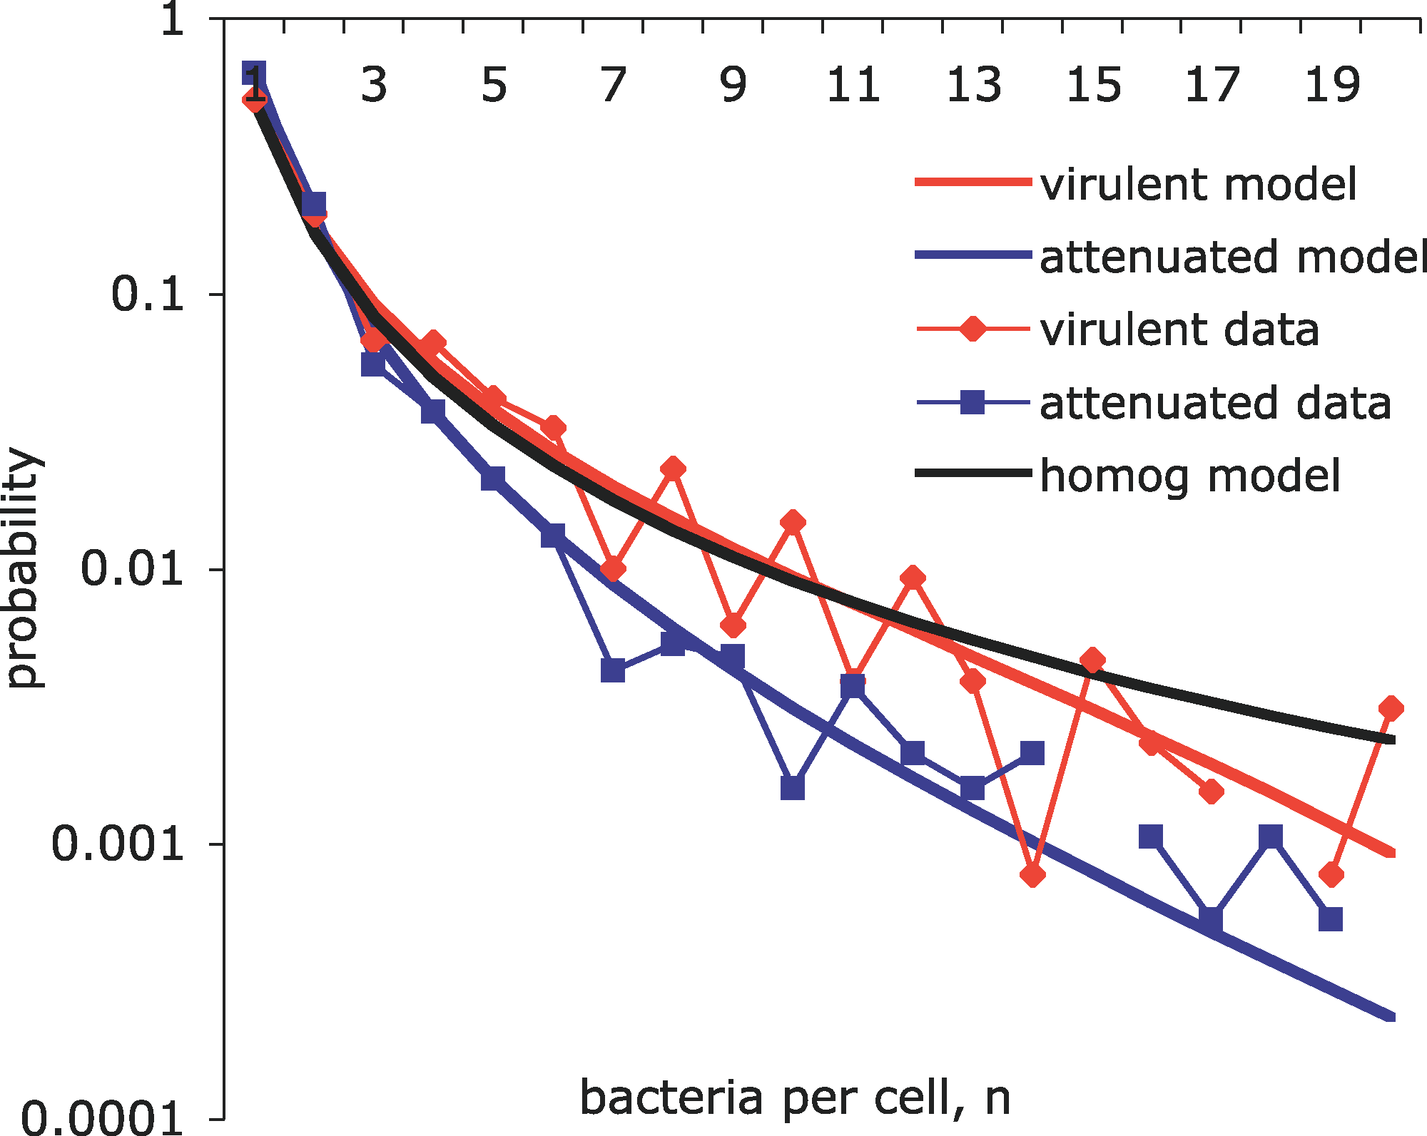
- distribution: two categories, or a range of burst sizes?
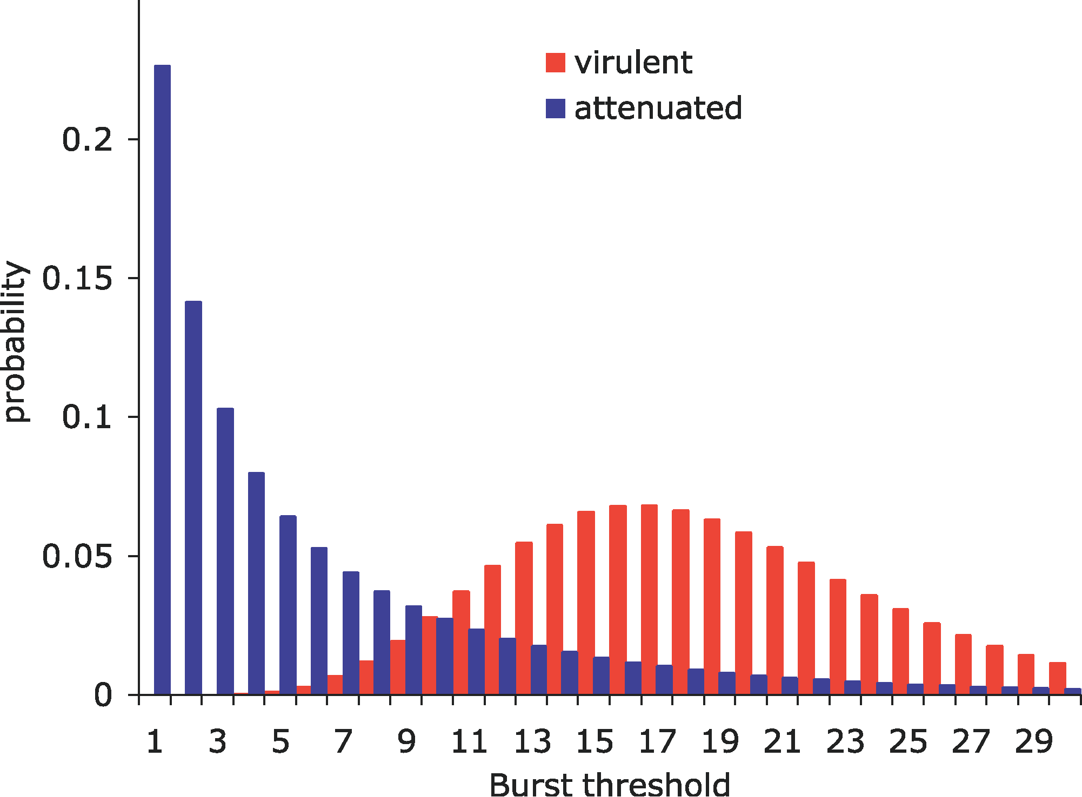
- “constitutive” vs “stochastic” models
- density-dependence in growth and/or burst probability?
- extracellular killing (bactericidal) vs slowing/preventing intracellular growth (bacteriostatic)
our analysis predicts that the efficacy of common extracellular antibiotics can be enhanced by supplementation with antibiotics slowing intracellular bacterial division [bacteriostatic drugs]. This implies that both bacteriostatic and bactericidal drugs can potentiate the therapeutic efficacy of extracellular antibiotics.

Bacterial dynamics in Drosophila
- Duneau et al. (2017)
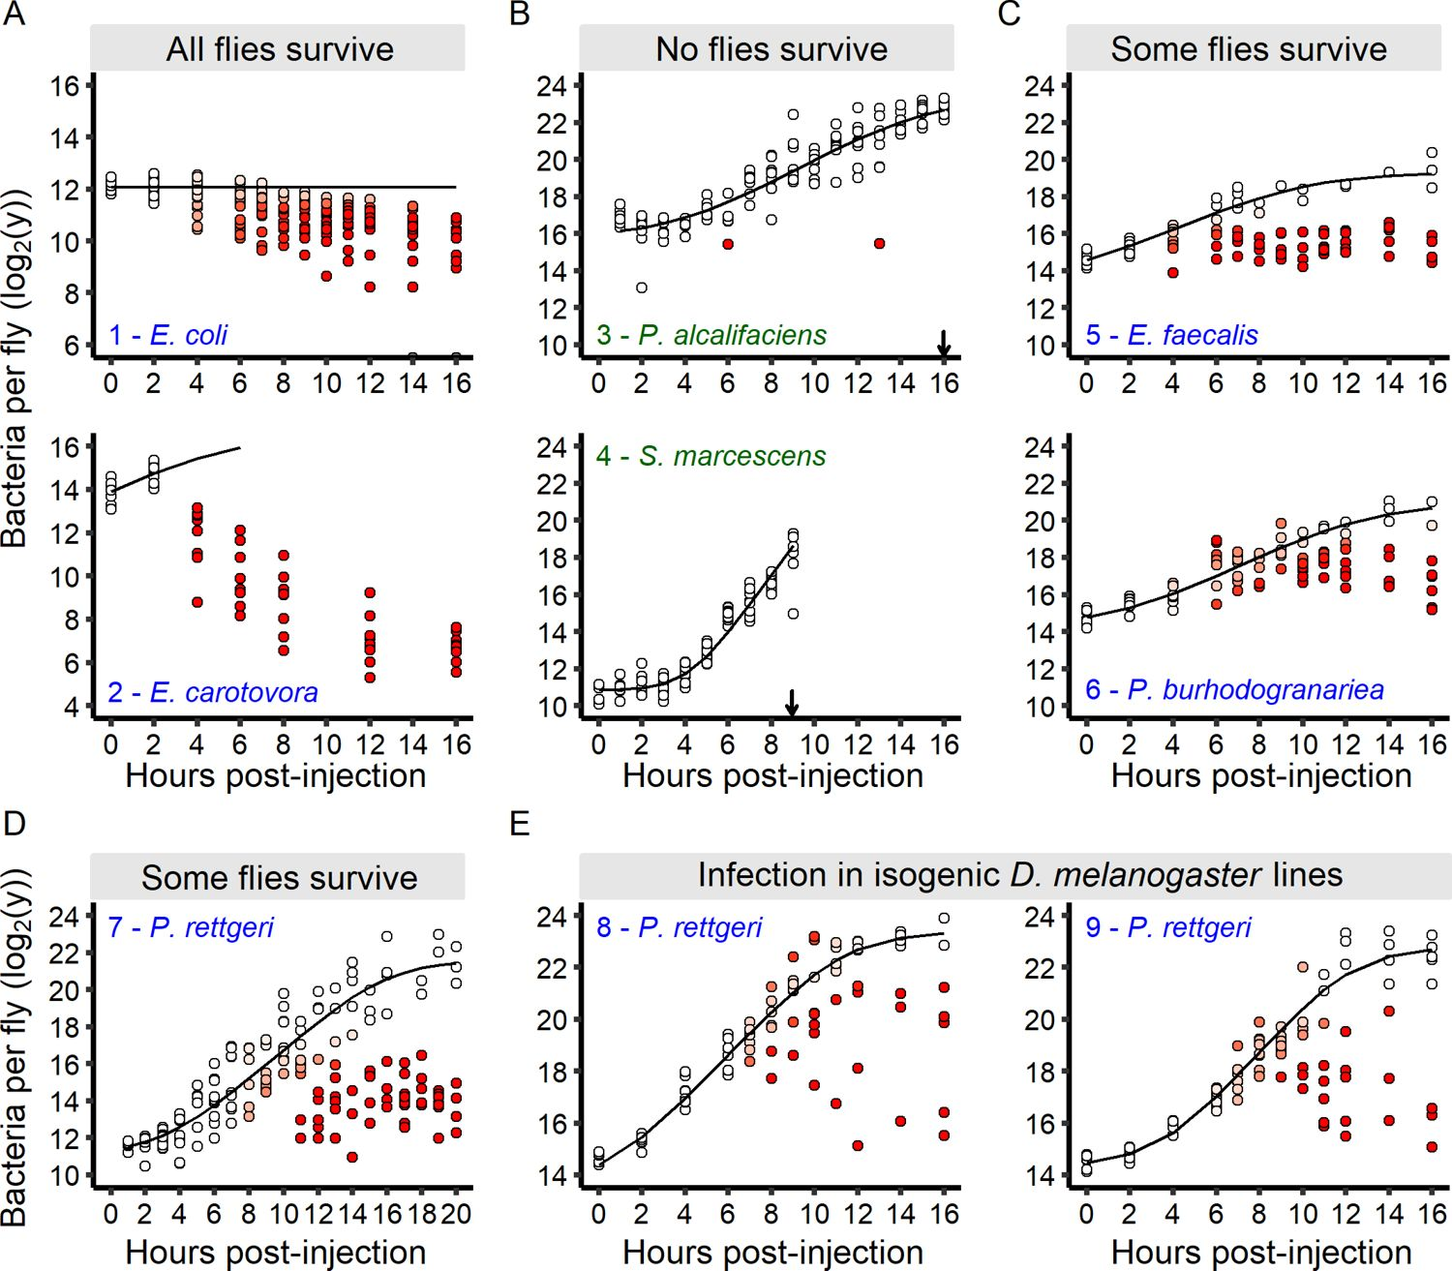
We have defined three parameters ($t^{c}$ [average time to control], $μ$ [early bacterial growth rate], $n^{\text{Tip}}$ [bacterial load above which the host cannot control infection]) that are sufficient to predict ultimate infection outcome, although we still do not know whether variation in those parameters is due to micro-environmental variation, uncontrolled plasticity in developmental history, somatic mutations, or other factors that are uncontrolled or uncontrollable in experiments (e.g. depth of penetration of the needle during injection, site at which bacteria accumulate etc.) and in nature (e.g. time since last meal or mating, psychological status of the fly etc.) …

References
Bonhoeffer, S, J M Coffin, and M A Nowak. 1997. “Human Immunodeficiency Virus Drug Therapy and Virus Load.” Journal of Virology 71 (4): 3275–78. http://www.ncbi.nlm.nih.gov/pmc/articles/PMC191463/.
Brown, Sam P, Stephen J Cornell, Mark Sheppard, Andrew J Grant, Duncan J Maskell, Bryan T Grenfell, and Pietro Mastroeni. 2006. “Intracellular Demography and the Dynamics of Salmonella Enterica Infections.” PLoS Biol 4 (11): e349. https://doi.org/10.1371/journal.pbio.0040349.
Duneau, David, Jean-Baptiste Ferdy, Jonathan Revah, Hannah Kondolf, Gerardo A Ortiz, Brian P Lazzaro, and Nicolas Buchon. 2017. “Stochastic Variation in the Initial Phase of Bacterial Infection Predicts the Probability of Survival in D. Melanogaster.” Edited by Bruno Lemaître. eLife 6 (October): e28298. https://doi.org/10.7554/eLife.28298.

Last updated: 2025-10-19 17:55:59.232552

